

**HOUSING: PRICE PREDICTION**

Submitted by:

PRANJAL DIKONDA

**ACKNOWLEDGMENT**

I would like to thank Flip Robo Technologies for providing me with the opportunity to work on this project from which I have learned a lot. I am also grateful to Mr. Shubham Yadav for his constant guidance and support.

Reference sources are :-

• Google

• Stackoverflow.com

• Notes and repository from DataTrained

• Krish Naik youtube videos

**INTRODUCTION**

* Business Problem Framing

Houses are one of the necessary need of each and every person around the globe and therefore housing and real estate market is one of the markets which is one of the major contributors in the world’s economy. It is a very large market and there are various companies working in the domain. Data science comes as a very important tool to solve problems in the domain to help the companies increase their overall revenue, profits, improving their marketing strategies and focusing on changing trends in house sales and purchases. Predictive modelling, Market mix modelling, recommendation systems are some of the machine learning techniques used for achieving the business goals for housing companies. Our problem is related to one such housing company.

We have to make a machine learning model by using some independent variable and predict the house price of particular variables.

* Conceptual Background of the Domain Problem

Real estate market is one of the markets which is one of the major contributors in the world’s economy.There is some sharp change in the real estate market of some countries .

The main cause for the increase of real estate market is the increase in population. As the population increase demand for property also increase.

Residental property is more costly than commercial as there is the role of demand and supply.

Similarly the price of property also depends on nearby social and economic conditions of property like the neighbourhood, crime rate, basic facilities like sewrage, freshwater,parks etc.

* Review of Literature

We are going to work on the dataset provided for building a model to predict the nature of future customers –

* 1. Uploading the dataset
  2. Data -preprocessing, removing unnecessary features
  3. Exploratory analysis of features
  4. Visualisaton of features, features along with target feature
  5. Data cleaning by removing outliers or missing values treatment
  6. Model pre-processing and model training
  7. Tesing multiple algorithms with multiple evaluation metrics
  8. Using the evaluation metrics best suited for our problem
  9. Hyper-parameter tuning using RandomisedSearchCV for the best model parameter
  10. Model prediction
  11. Saving the final model
* Motivation for the Problem Undertaken

Every person needs a house to live. But not all of them able to find suitable match for their requirements. Due to the rise in property rates day by day ,it becomes hard for people to get a house in their budget and even for the companies to form a better strategy to focus on customers without knowing them well.

Data science comes as a very important tool to solve problems in the domain to help the companies increase their overall revenue, profits, improving their marketing strategies and focusing on changing trends in house sales and purchases. Predictive modelling, Market mix modelling, recommendation systems are some of the machine learning techniques used for achieving the business goals for housing companies. Our problem is related to one such housing company.

**Analytical Problem Framing**

* Mathematical/ Analytical Modeling of the Problem

In this project we have used mathematical and stastistical methods to find the best result out of the data.

Firstly, we are using descriptive analysis to find the information about mean ,median, percentiles ,standard deviation ,minimum and maximum values.

Then we find the descriptive analysis of Target variable i.e. “SalePrice”.

After that by using the correlation method ,we find the correlation percentage between target variables and independent variabels. We draw a table which gives the correlation of each variable with each other.

After the mathematical and stastistical modelling we use analytical modelling for finding the insights from our dataset. Graphically method is the best method to find some outcomes from the dataset as human eye can’t understand the raw data there we need graphs to understand the relations, patterns from the data.

Descriptive Analysis :

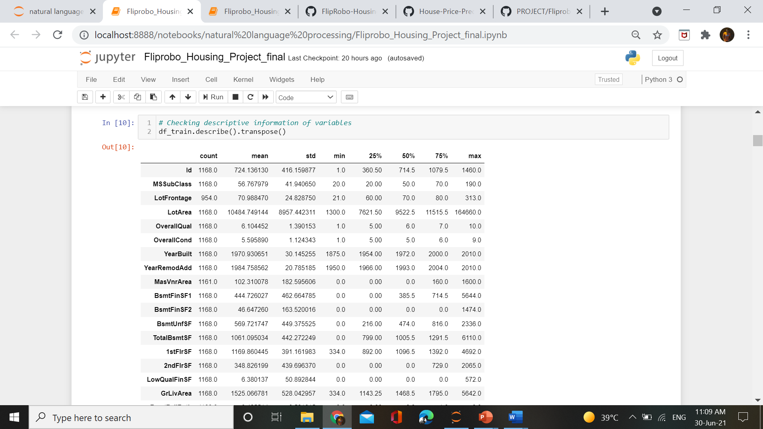

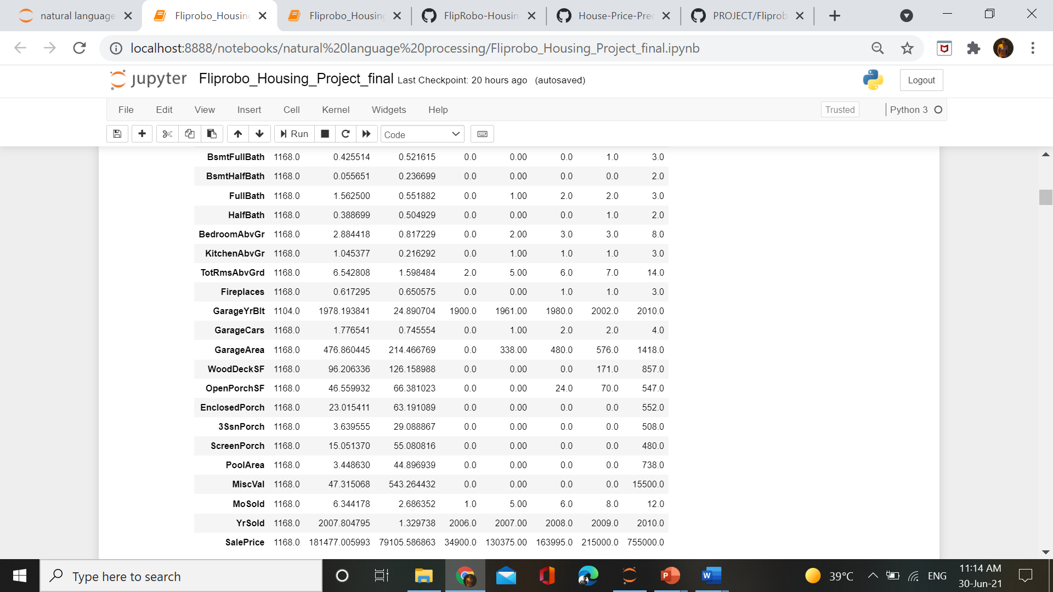

**Observations from descriptive analysis:**

1. `MasVnrArea, BsmtFinSF2, BsmntHalfBath, BsmtfullBath, HalfBath, 2ndFlrSF, LowQualFinSF, WoodDeckSF, EnclosedPorch, 3SsnPorch, ScreenPorch, MiscVal` are having mean equal to 0 and mean greater than 0(in some cases far greater than 0) which clearly suggests the presence of many outliers along with high positive skewness in the variable.
2. `OpenPorch, GrLivArea, 1stFlrSF, TotalBsmtSF, BsmtUnfSF, BsmtFinSF1, MsSubClass, LotArea ` these variables having mean greater than median which shows positive skewness present in variables with some outliers.
3. `MiscVal, PoolArea, ScreenPorch, 3SsnPorch, EnclosedPorch, BsmtHalfBath ` Some variables having `minimum values 0, 25th percetile also 0, and some upto 75th percentile values equal to 0` while 100th percentile is far greater than zero..
4. `LotArea` having highest standard deviation `8957.442311` which means that data not normally distributed.
5. There is `huge difference in variables values`. Some having `small range values while some high range` values. It may impact the model efficiency if we use the dataset without scaling in proper format.

Descriptive Analysis of Target Variable :

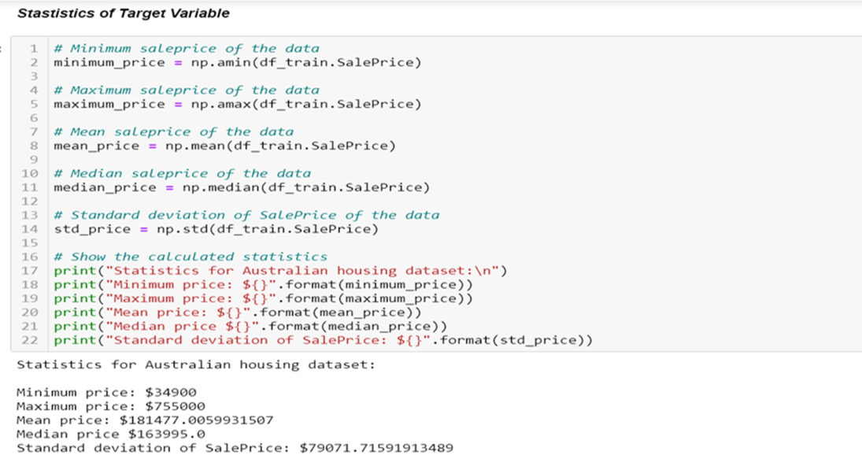

Descriptive Analysis of Variables – Correlation

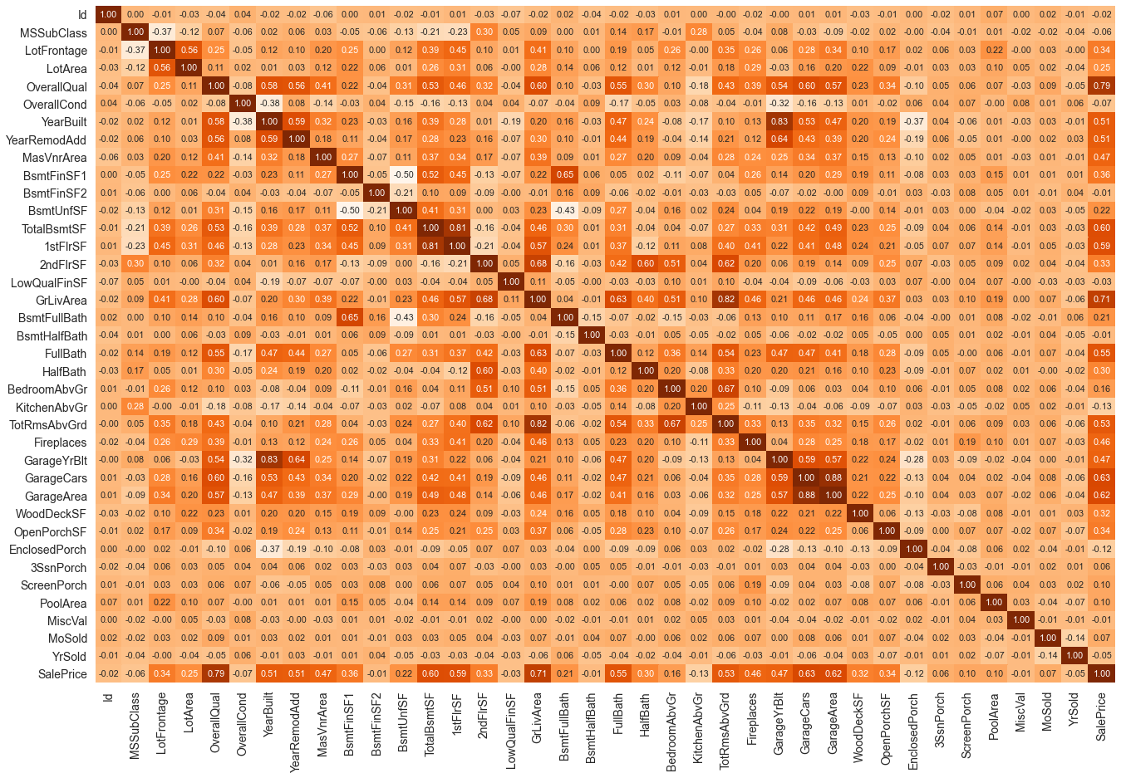

**Observations** :

1. OverallQual (Overall quality) is the highest correlated variables among all. It is `80% directly` correlated with the target variable, which means that the increase in OverallQual of house will going to increase the SalePrice of house or vice-versa.
2. After OverallQual, `GrLivArea (Grid Living Area)` is in more than `70% direct` correlation with target variable.
3. Almost all the variables with some correlation above `20%-30%` are in direct relationship with target variable.
4. Some variables like `KitchenAbvGr, EnclosedProch,` etc are indirectly correlated with Target variable but the degree of correltaion is very low.
5. While some cases are present where there is high direct and indirect relationship between independent variables. It will create a problem of multicollinearity and it may distort our model efficiency.
6. *Variables like `GarageYrBuilt` and `YrBuilt` are having above 80% of direct correlation.
7. `TotalRmsAbvGrd and GrLivArea` also having 80% direct correlation.
8. ` GarageArea and GarageCars` having 88% direct correlation.
9. While `BsmntUnf and BsmtFinSf1` having 50% indirect correlation wiht each other.
10. BsmntFullBath and BsmntUnf` having 43% of indirect correaltionwihteacch other.

* Data Sources and their formats

Our data source is FlipRoboTechnologies, who provided the data in csv format during my internship program.

This dataset contains total of 1460 rows and 81 columns but for train data we have 1168 rows and 81 columns ,rest of the data for testing the model.

* # Column Non-Null Count Dtype
* --- ------ -------------- -----
* 0 Id 1168 non-null int64
* 1 MSSubClass 1168 non-null int64
* 2 MSZoning 1168 non-null object
* 3 LotFrontage 954 non-null float64
* 4 LotArea 1168 non-null int64
* 5 Street 1168 non-null object
* 6 Alley 77 non-null object
* 7 LotShape 1168 non-null object
* 8 LandContour 1168 non-null object
* 9 Utilities 1168 non-null object
* 10 LotConfig 1168 non-null object
* 11 LandSlope 1168 non-null object
* 12 Neighborhood 1168 non-null object
* 13 Condition1 1168 non-null object
* 14 Condition2 1168 non-null object
* 15 BldgType 1168 non-null object
* 16 HouseStyle 1168 non-null object
* 17 OverallQual 1168 non-null int64
* 18 OverallCond 1168 non-null int64
* 19 YearBuilt 1168 non-null int64
* 20 YearRemodAdd 1168 non-null int64
* 21 RoofStyle 1168 non-null object
* 22 RoofMatl 1168 non-null object
* 23 Exterior1st 1168 non-null object
* 24 Exterior2nd 1168 non-null object
* 25 MasVnrType 1161 non-null object
* 26 MasVnrArea 1161 non-null float64
* 27 ExterQual 1168 non-null object
* 28 ExterCond 1168 non-null object
* 29 Foundation 1168 non-null object
* 30 BsmtQual 1138 non-null object
* 31 BsmtCond 1138 non-null object
* 32 BsmtExposure 1137 non-null object
* 33 BsmtFinType1 1138 non-null object
* 34 BsmtFinSF1 1168 non-null int64
* 35 BsmtFinType2 1137 non-null object
* 36 BsmtFinSF2 1168 non-null int64
* 37 BsmtUnfSF 1168 non-null int64
* 38 TotalBsmtSF 1168 non-null int64
* 39 Heating 1168 non-null object
* 40 HeatingQC 1168 non-null object
* 41 CentralAir 1168 non-null object
* 42 Electrical 1168 non-null object
* 43 1stFlrSF 1168 non-null int64
* 44 2ndFlrSF 1168 non-null int64
* 45 LowQualFinSF 1168 non-null int64
* 46 GrLivArea 1168 non-null int64
* 47 BsmtFullBath 1168 non-null int64
* 48 BsmtHalfBath 1168 non-null int64
* 49 FullBath 1168 non-null int64
* 50 HalfBath 1168 non-null int64
* 51 BedroomAbvGr 1168 non-null int64
* 52 KitchenAbvGr 1168 non-null int64
* 53 KitchenQual 1168 non-null object
* 54 TotRmsAbvGrd 1168 non-null int64
* 55 Functional 1168 non-null object
* 56 Fireplaces 1168 non-null int64
* 57 FireplaceQu 617 non-null object
* 58 GarageType 1104 non-null object
* 59 GarageYrBlt 1104 non-null float64
* 60 GarageFinish 1104 non-null object
* 61 GarageCars 1168 non-null int64
* 62 GarageArea 1168 non-null int64
* 63 GarageQual 1104 non-null object
* 64 GarageCond 1104 non-null object
* 65 PavedDrive 1168 non-null object
* 66 WoodDeckSF 1168 non-null int64
* 67 OpenPorchSF 1168 non-null int64
* 68 EnclosedPorch 1168 non-null int64
* 69 3SsnPorch 1168 non-null int64
* 70 ScreenPorch 1168 non-null int64
* 71 PoolArea 1168 non-null int64
* 72 PoolQC 7 non-null object
* 73 Fence 237 non-null object
* 74 MiscFeature 44 non-null object
* 75 MiscVal 1168 non-null int64
* 76 MoSold 1168 non-null int64
* 77 YrSold 1168 non-null int64
* 78 SaleType 1168 non-null object
* 79 SaleCondition 1168 non-null object
* 80 SalePrice 1168 non-null int64

In 81 columns of data ,3 datatypes are present :

1. Float datatype in 3 columns
2. Integer64 datatype in 35 columns
3. Object datatype in 43 columns.

* Data Preprocessing Done

**Data Preprocessing** is the major step before model building as without proper cleaning ,proper formatting and understanding the data we cannot build an efficient model. So Data Preprocessing being the major step is done by following ways :

* 1. Importing the suitable libraires and then load the data
  2. Checking null values
  3. Filling null values with suitable data
  4. Feature Engineering
  5. Outliers Treatment
  6. Correcting Skewness
  7. Data Encoding and Scaling

**Importing the suitable libraires and then load the data**: First step in data preprocessing is importing the libraires which will be helpful in model building and then load the data. After loading we will check the shape ,information of dataset.

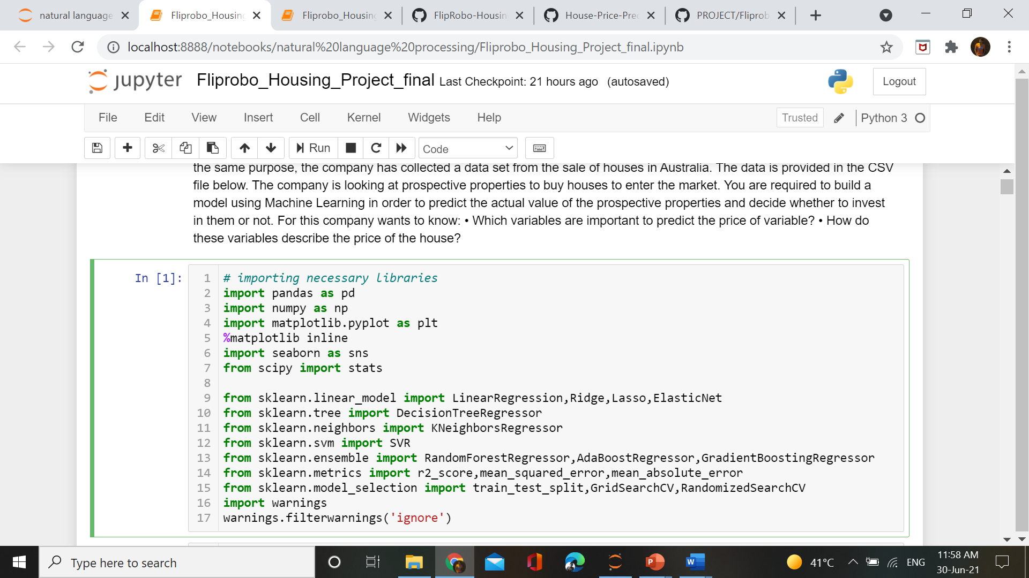

Loading the data

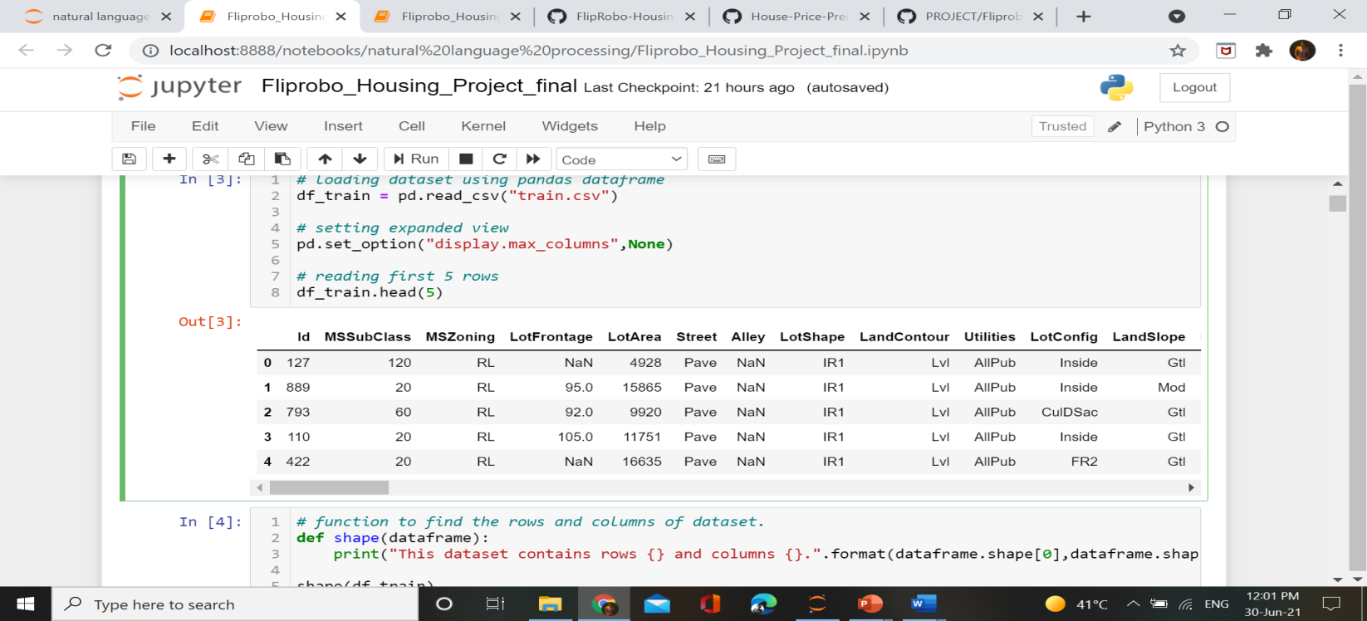

**Checking null values :**

As now we have loaded the data we will check the null values present in dataset. For checking the null values we have created a function which will show us the percentage of missing values in columns along with the graph.

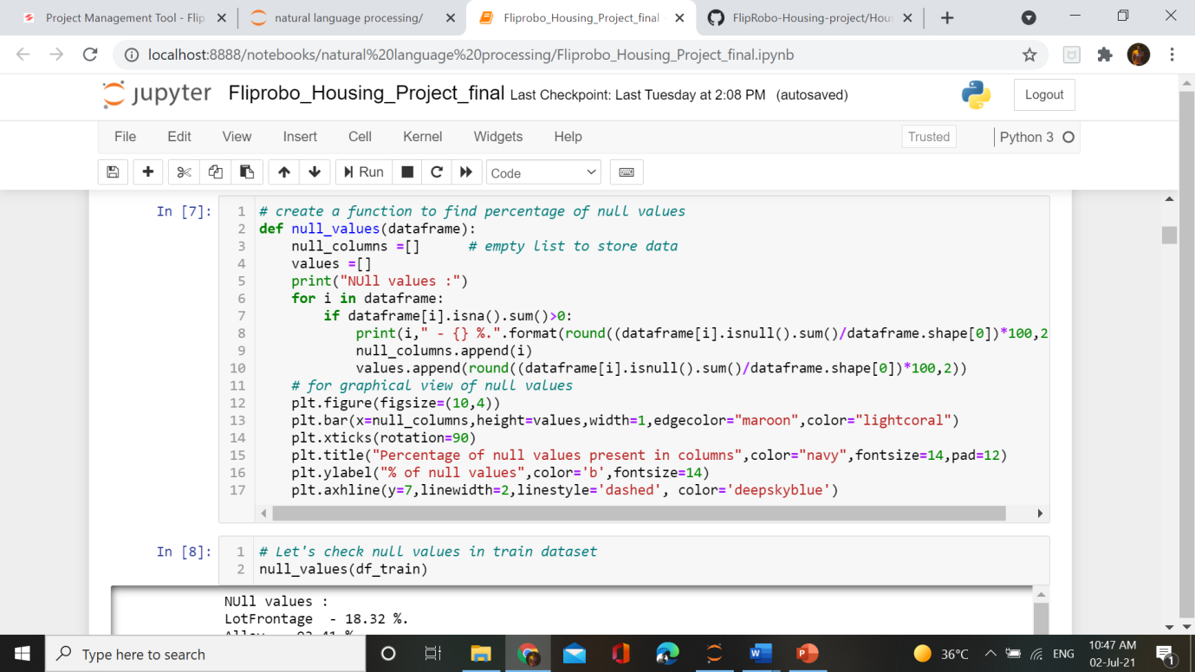

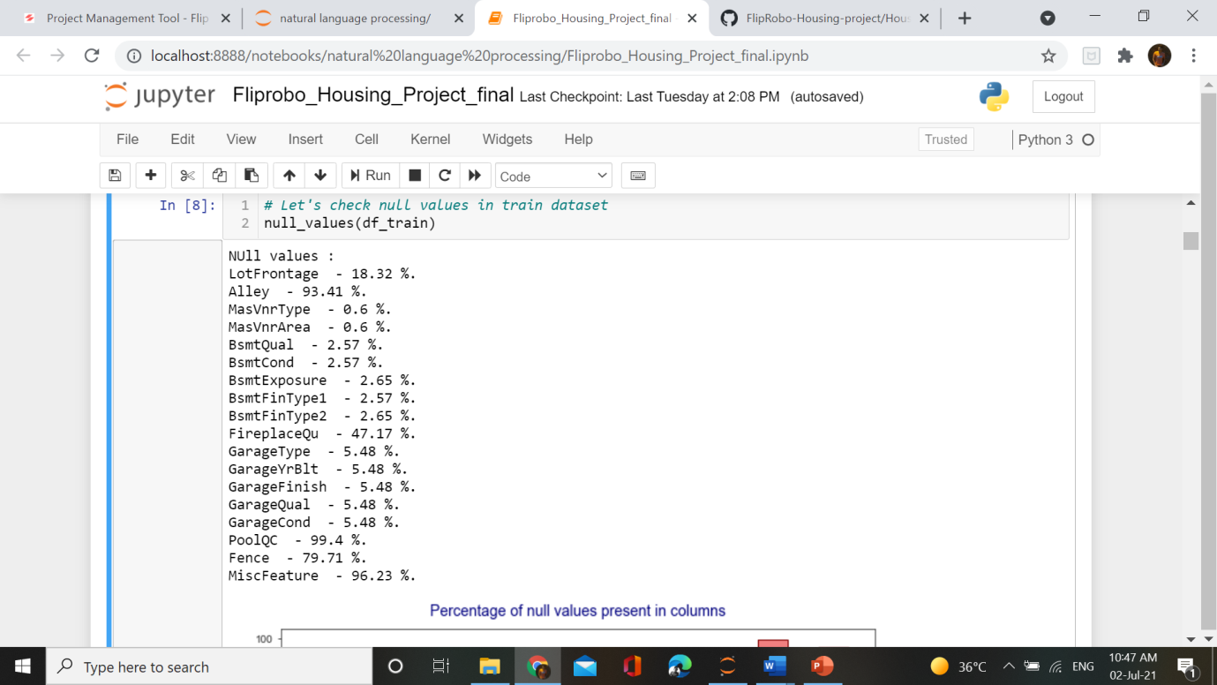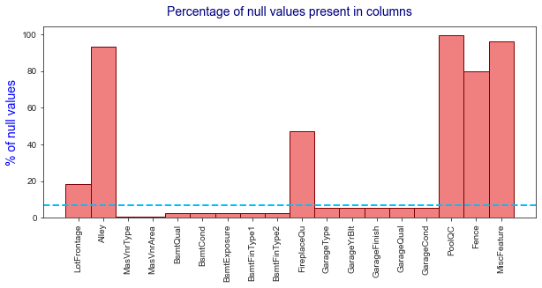

**Observations** :¶

1. from above we can clearly see that 4 variables contains null values more than 80% of total data.
2. PoolQC contains null values - 99.4 %
3. MiscFeature contains null values - 96.23 %
4. Fence contains null values - 79.71 %
5. Alley contains null values - 93.41 %
6. While the blue line is drawn at 7% of missing values, below this line we can drop the missing values and it will notimpact ourprediction so much, but dropping above it will be more data loss which will not be suitable for our model.
7. So 9-10 variables contains missing values less than 7%.

**Filling null values with suitable data:**

By checking the missing values in columns we can assume that some of the conditions like FirePlace, Basement ,Garage may not be present in houses while collecting the data that’s why these columns containing missing values. So keeping this in mind we fill the null values with “No Fireplace, No Garage, No Baement” in those filled where this condition is applied. While in continuous variables we fill with mean or median values.

**Feature Engineering :**

Feature Engineering is also a major step of data preprocessing. This steps helps in formatting the variable in such a way that it become easy to understand. We can also drop unnecessary columns and convert columns into another formats like can convert Full Date column into Year column, Month column etc.

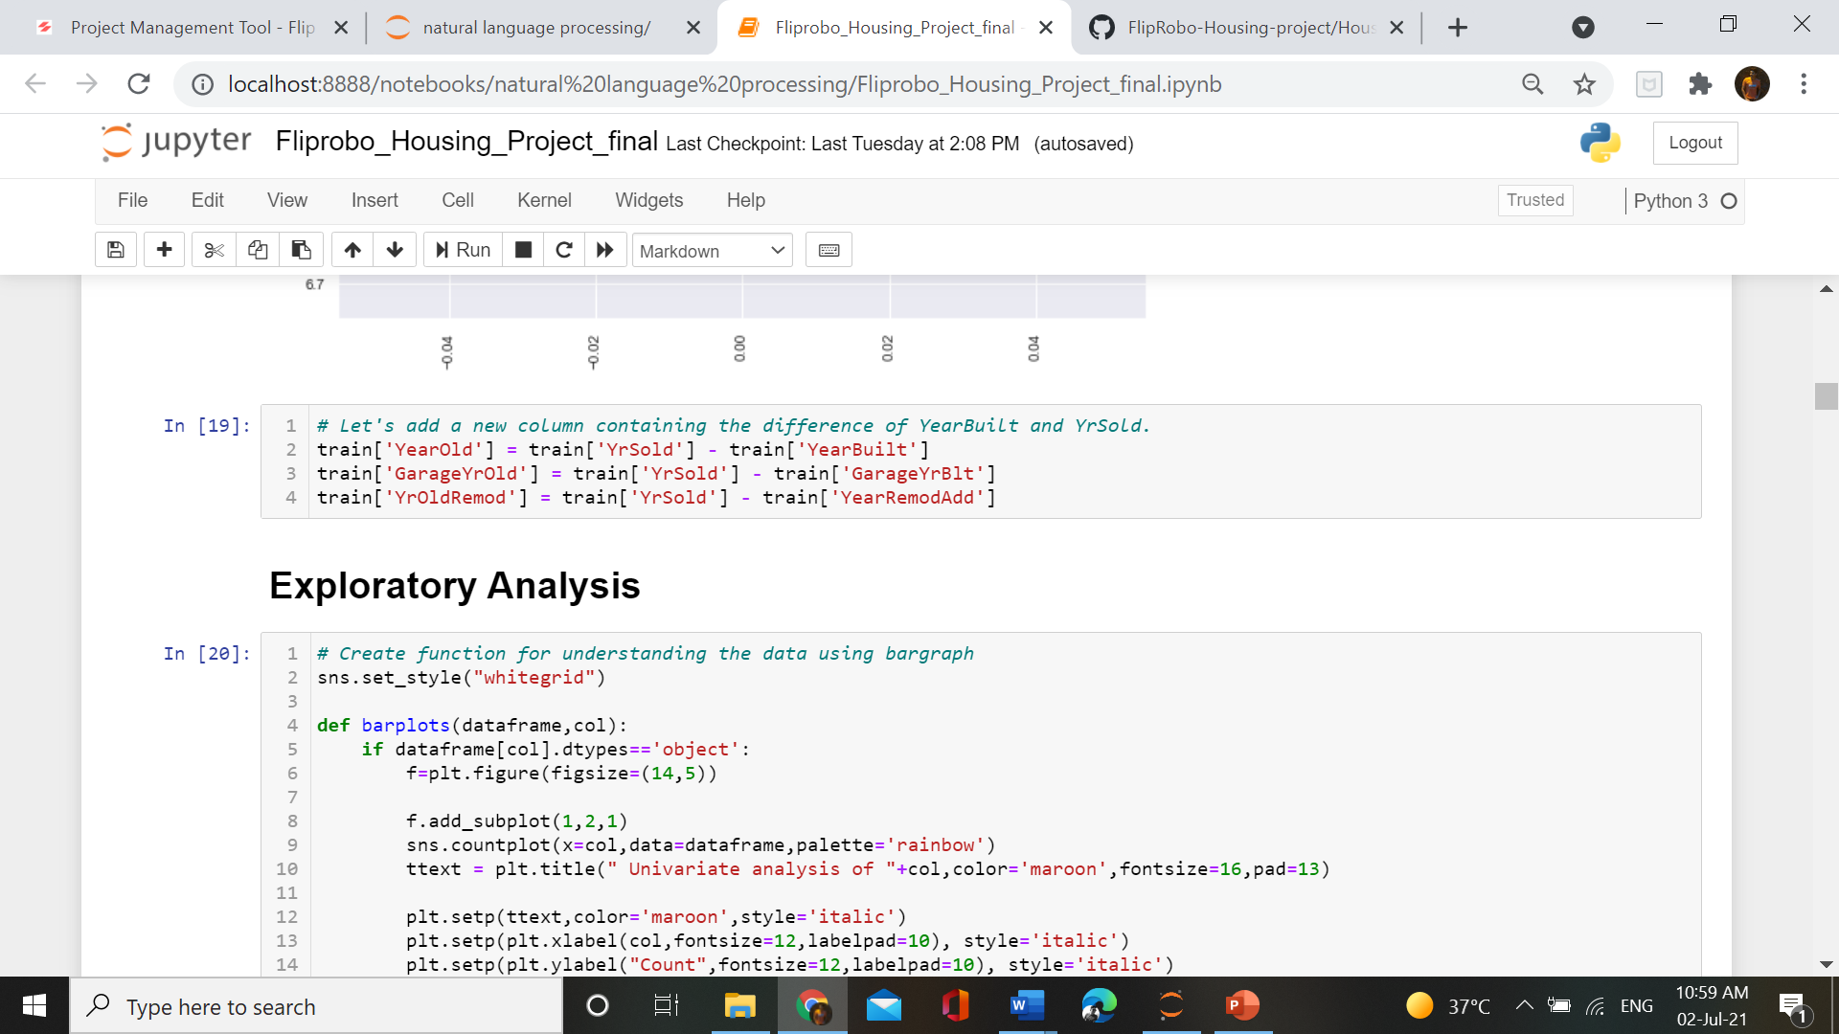

**OultiersTreatment :**

From the mathematically modelling we find out that out dataset contains a lot of outliers. So we can treat outliers by using different techniques. In this we had used Winsorization technique which will remove the outliers by setting the upper and lower limit.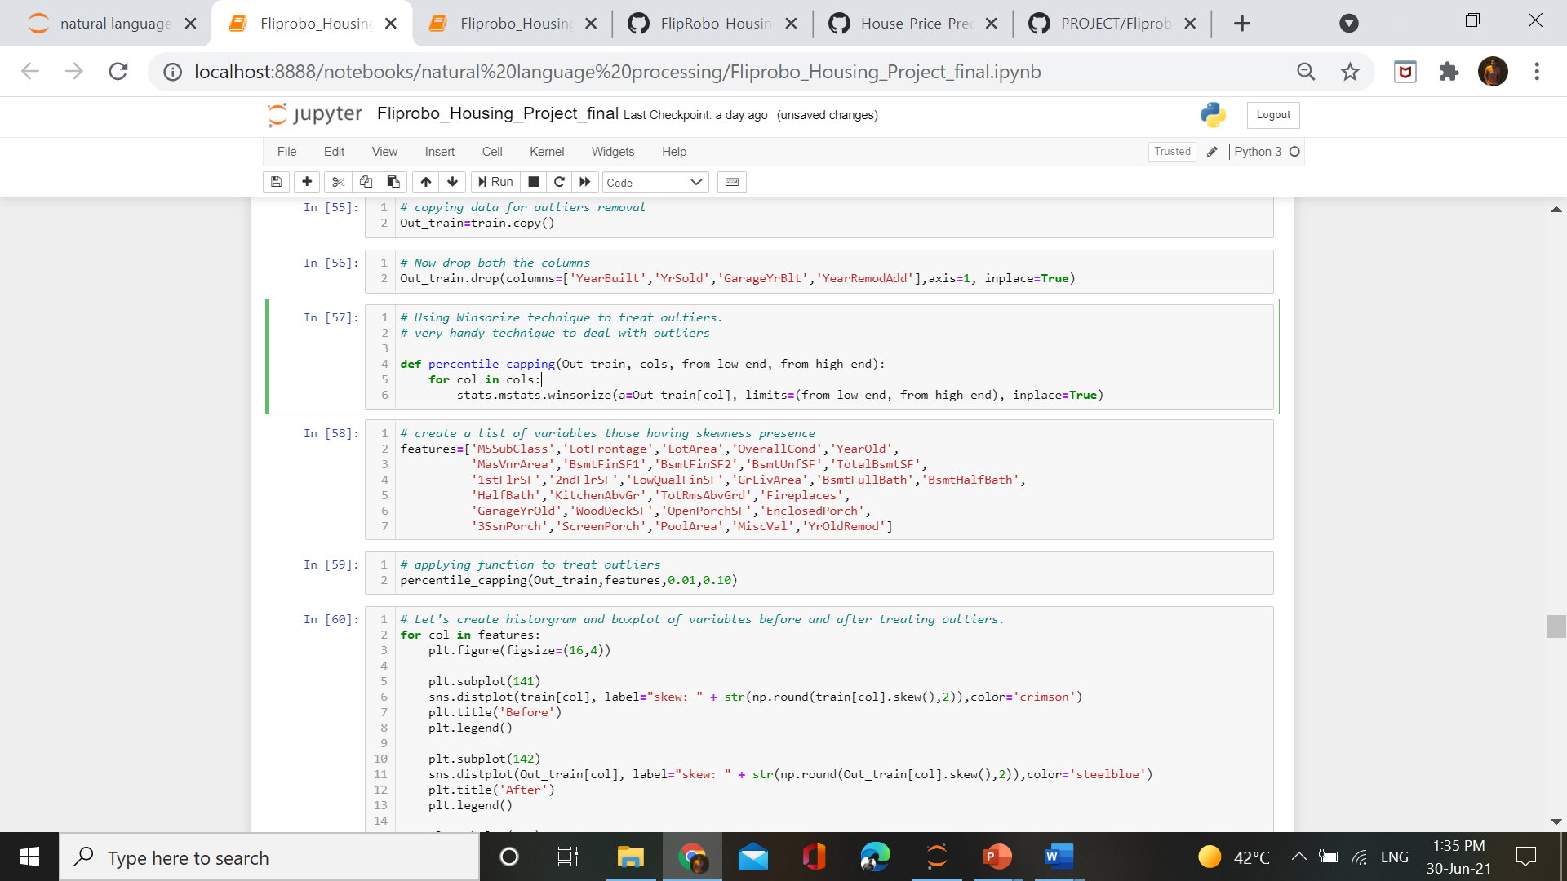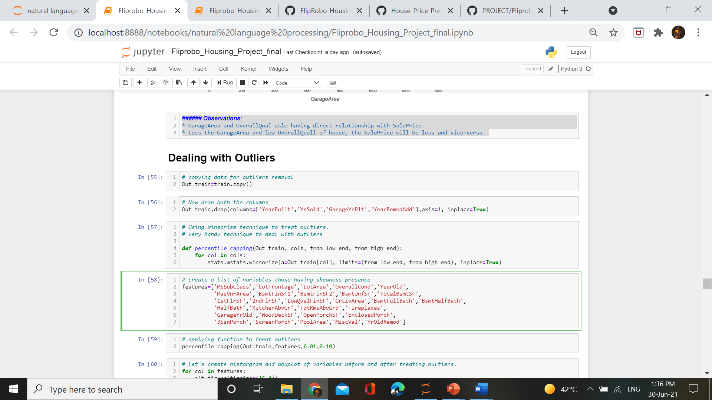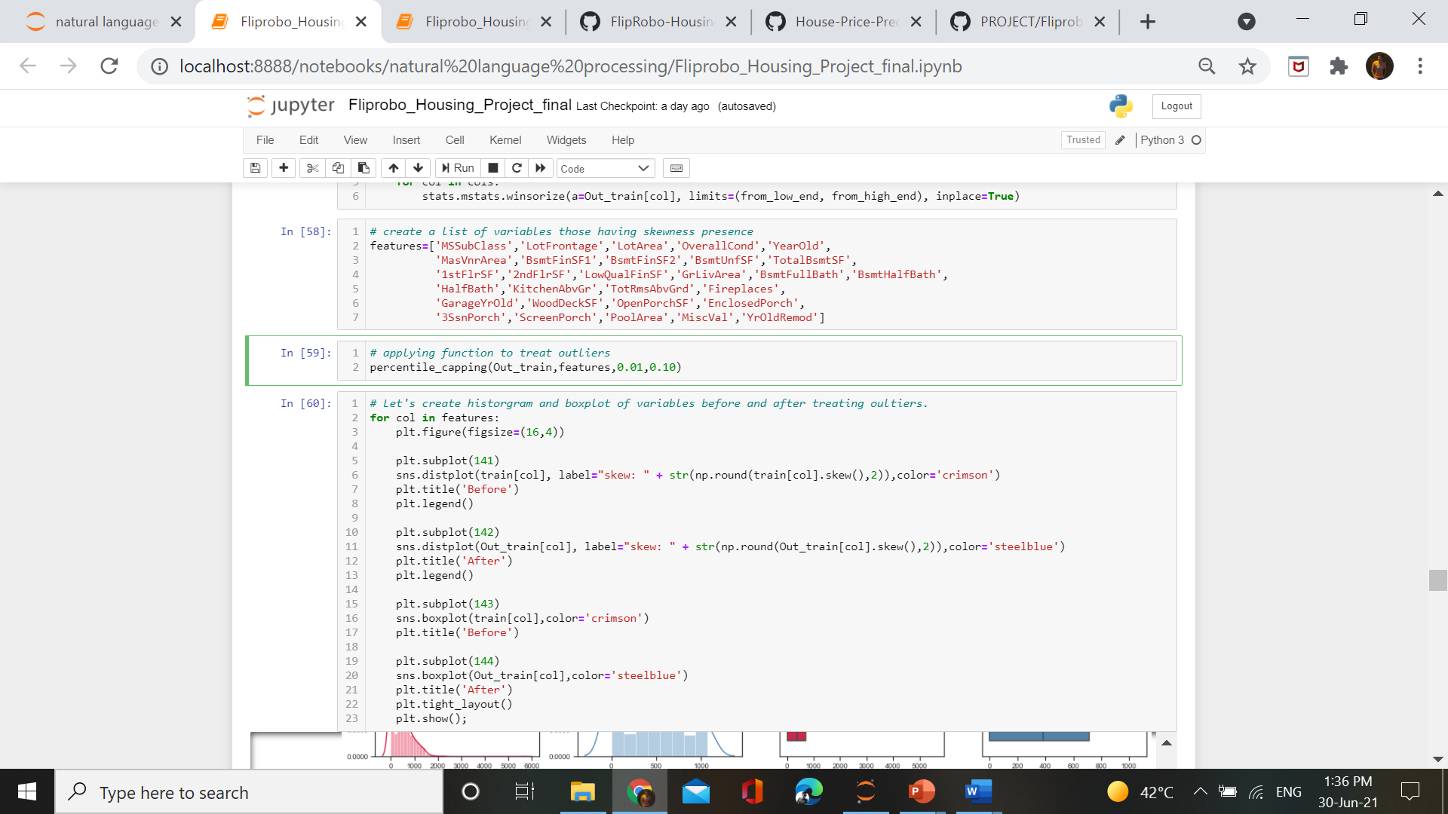

Result –

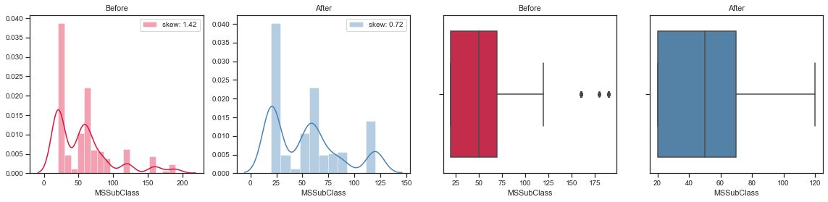

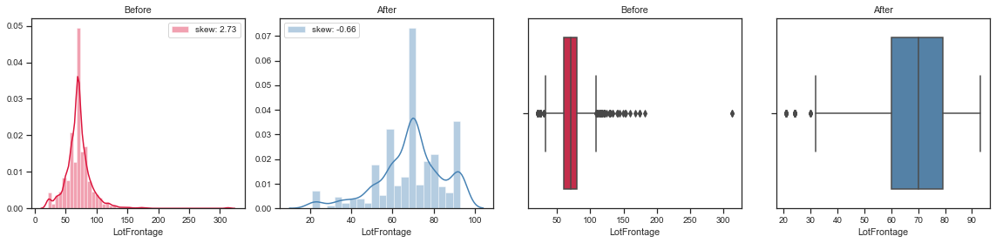and so on many variables.

**Correcting skewness :**

As above we find out that skewness is also present in lot of variabels. So after treating outliers we already deal with a lot of outliers. But some skewness is left we used SquareRoot method to deal with skewness.

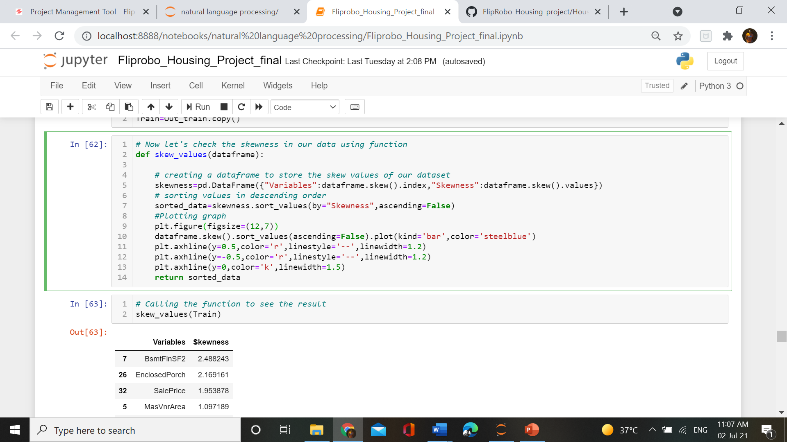

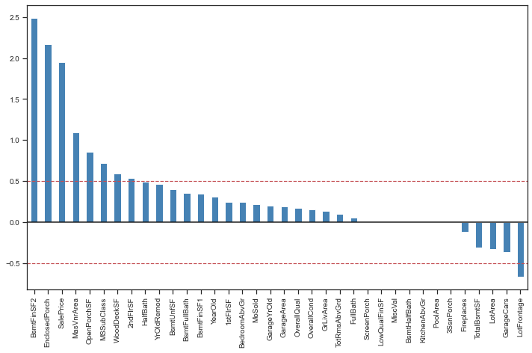

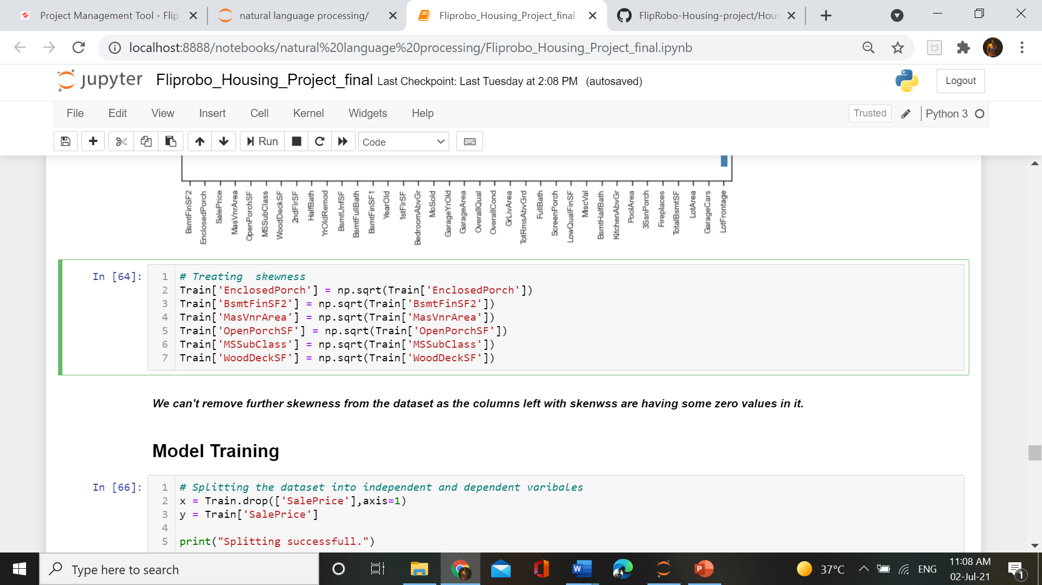

We treated skewness using above methods.

**Data Encoding and Scaling**:

Now as we have treated the outiers and skewness ,next step is to label the data and after labelling we will scale our data so that model will not be biased.

For Labelling we had used LabelEncoder which would label the categorical data into numerical data.

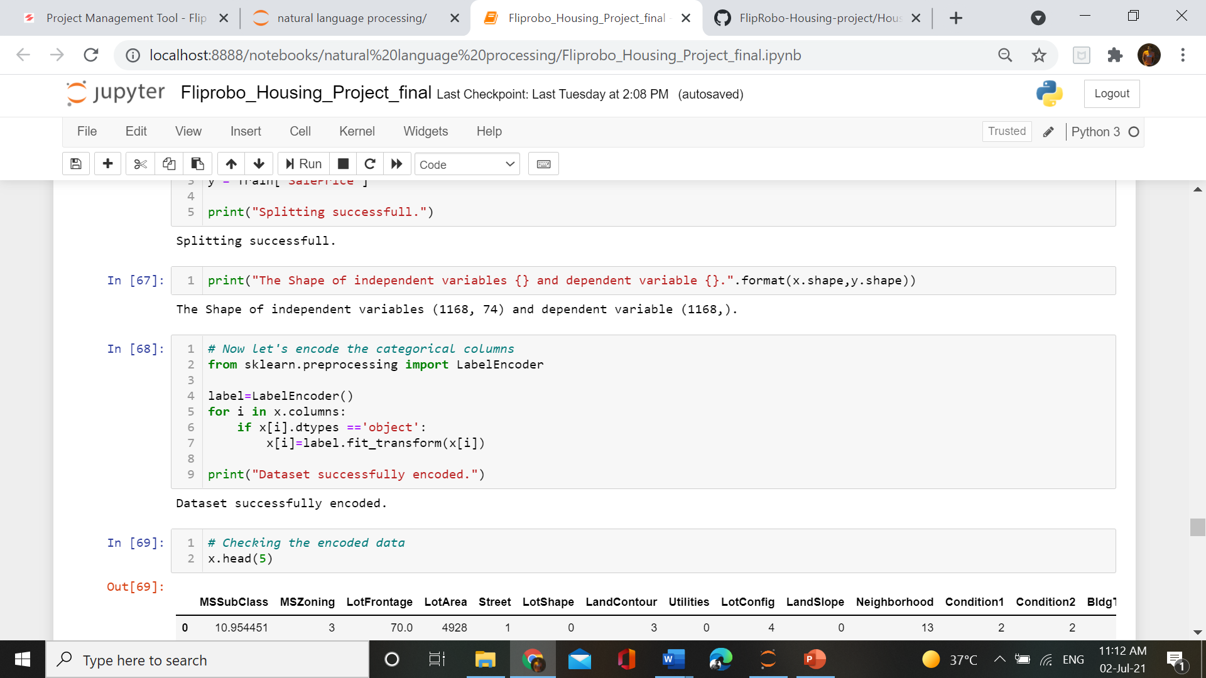

After labelling we scaled it using StandardScaler library –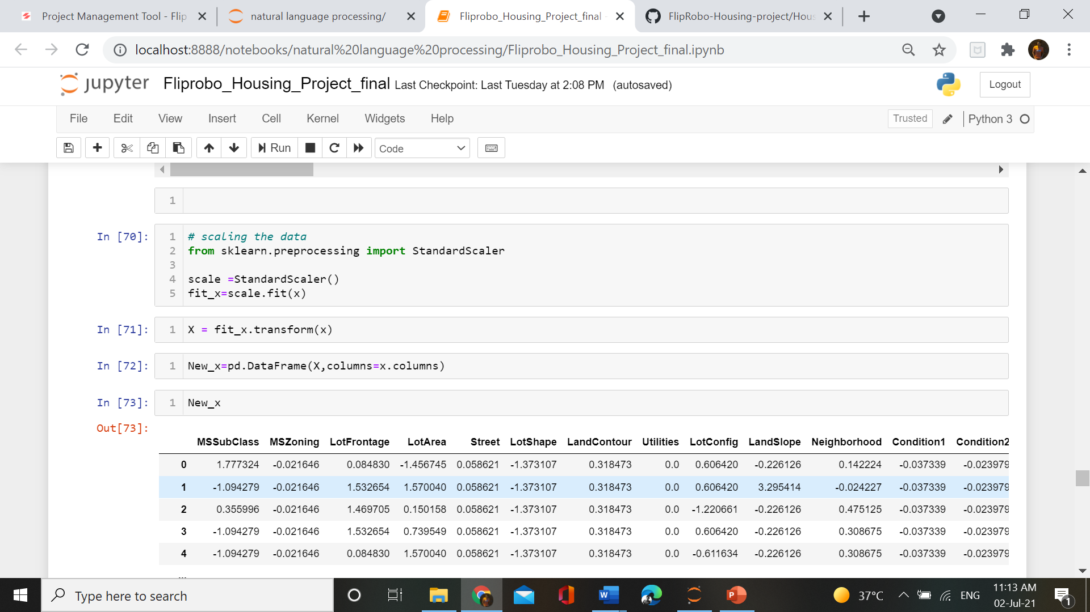

Now we are good to go for model-building.

* Data Inputs- Logic- Output Relationships

For describing the input-output relationship we have used Correlation of independent and dependent variabels. It would be easy to understand the relationship using the graph.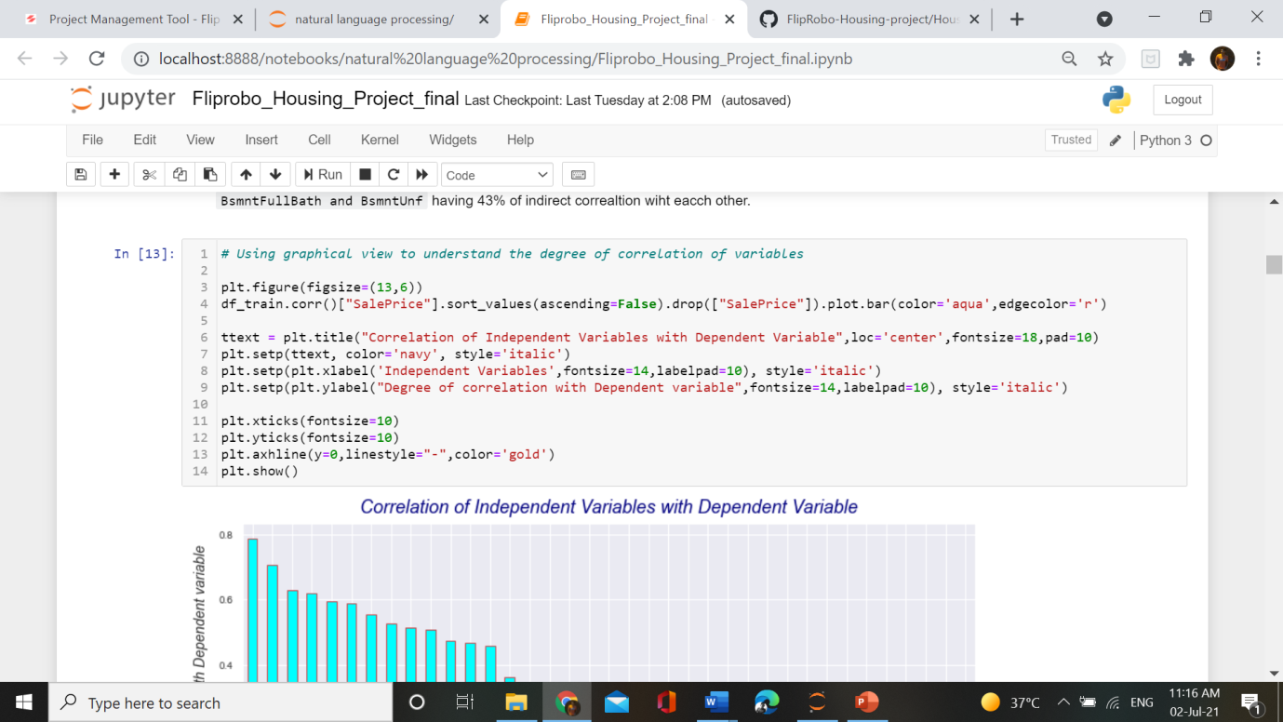

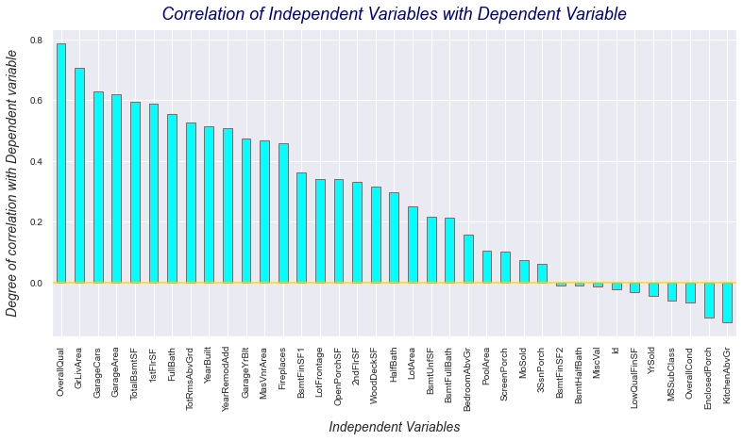

###### Observations :

1. As seen using heatmap, OverallQual is the most correlated variable with target variable and then GrLivArea ,GarageCars ,GarageArea etc.
2. Number of KitchenAbvGr will signify that there is indirect relationship with target variable. More the number less will be the SalePrice. Through it we can say that people will not prefer more kitchen above grounds.
3. Variables like BsmtHalfBath, BsmtFinSF2, MiscVal and id are having no relationship with target variable.

* Hardware and Software Requirements and Tools Used

There is no such requirement for hardware ,but I have used intel i5 8th generation processor.

Software: Jupyter Notebook (Anaconda 3) ,Microsoft Word

Language: Pythhon

Libraries used in project:

1. Pandas
2. Numpy
3. Matplotlib
4. Seaborn
5. Sklean
6. Stats

* **For data loading and analysis**
* **a). import pandas as pd –**Pandas is a [software library](https://en.wikipedia.org/wiki/Software_library) written for the [Python programming language](https://en.wikipedia.org/wiki/Python_(programming_language)) for data manipulation and analysis. In particular, it offers data structures and operations for manipulating numerical tables and [time series](https://en.wikipedia.org/wiki/Time_series).
* **b). import numpy as np –** Numpy is a library for the [Python programming language](https://en.wikipedia.org/wiki/Python_(programming_language)), adding support for large, multi-dimensional [arrays](https://en.wikipedia.org/wiki/Array_data_structure) and [matrices](https://en.wikipedia.org/wiki/Matrix_(math)), along with a large collection of [high-level](https://en.wikipedia.org/wiki/High-level_programming_language) [mathematical](https://en.wikipedia.org/wiki/Mathematics) [functions](https://en.wikipedia.org/wiki/Function_(mathematics)) to operate on these arrays
* **For data visualization**
* **a). import matplotlib.pyplot as plt –** Matplotlib is a plotting library used for data visualization.
* **b). import seaborn as sns -**Seaborn is also a plotting library. It is more advanced than matplotlib but works with matplotlib.
* **Model-preprocessing libraries**
* **from sklearn.preprocessing import LabelEncoder –** ML algorithm understands numerical data only, so for converting categorical data into numerical data LabelEncoder library is used.
* from sklearn.preprocessing import StandardScaler – StandardScaler library is used to scale the data. As different columns have different range of data, dure to this difference model will become biased. It will give more importance to those features who have high range. So to remove this possibility we use StandardScaler.
* **Fromsklearn.model_selection import train_test_split,cross_val_score *–***
* Train_test_split is a function in Sklearn model selection for splitting data arrays into two subsets: for training data and for testing data. With this function, you don't need to divide the dataset manually. By default, Sklearntrain_test_split will make random partitions for the two subsets

**Model/s Development and Evaluation**

* Identification of possible problem-solving approaches (methods)

As we all know ,known target data is treated under Supervised Machine Learning Model and Supervised ML models deals with continuous and discrete data type. If our target data is continuous in nature then Regression Algorithms will be used but if data is discrete in nature/categorical data ,then Classification algorithms will be used.

Let’s check our target data for identification of problem-

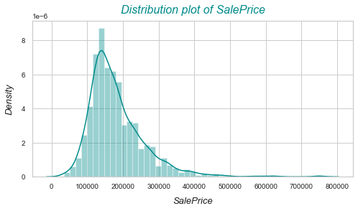

So seeing the graph we can clearliy that it is a regression problem. We have to deal Regression Algoritms in model building.

* Testing of Identified Approaches (Algorithms)

In our project we have used a lot of algorithms :

1. Linear Regression
2. Ridge Regression
3. Lasso Regression
4. ElasticNet Regression
5. DecisionTree Regression
6. KNeighbors Regression
7. RandomForest Regression
8. GradientBoosting Regression
9. AdaBoost Regression

* Run and Evaluate selected models

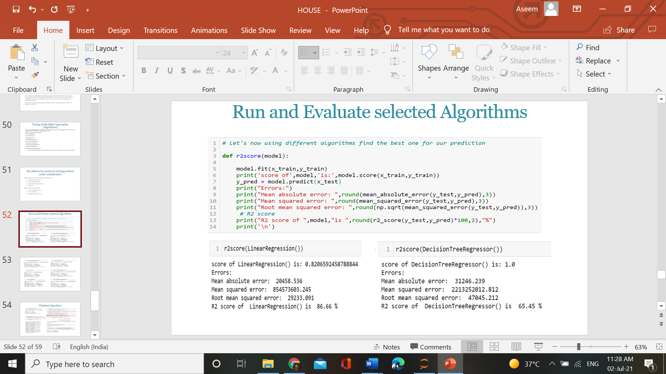

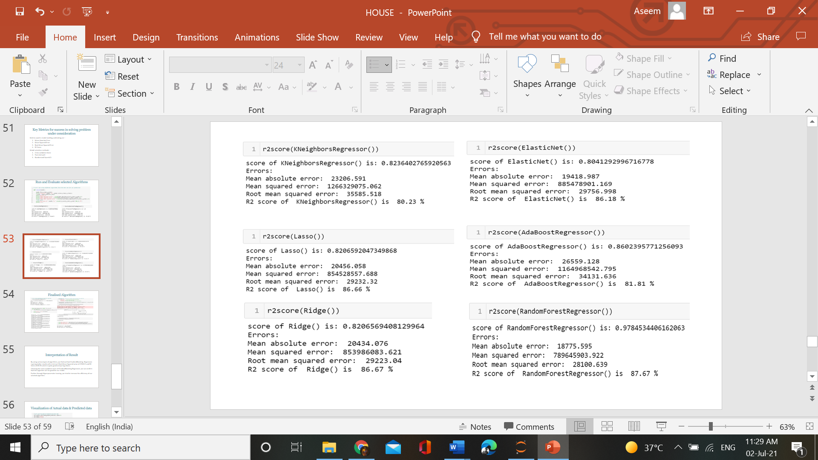

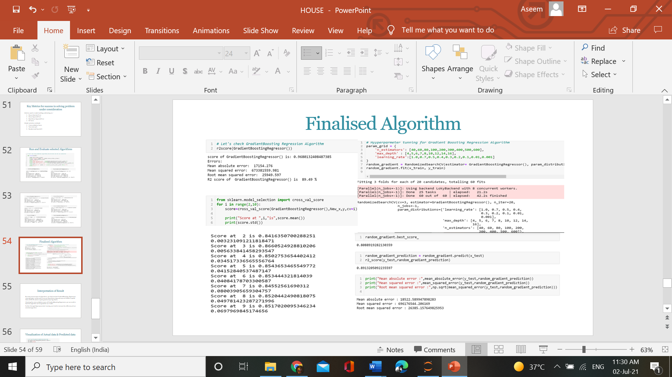

* Key Metrics for success in solving problem under consideration
* Mean Absolute Error– MAE is a measure of errors between paired observations expressing the same phenomenon. Examples of Y versus X include comparisons of predicted versus observed, subsequent time versus initial time, and one technique of measurement versus an alternative technique of measurement.
* Mean squared Error – measures the average of the squares of the errors—that is, the average squared difference between the estimated values and the actual value.
* Root mean squared error – RMSE is a frequently used measure of the differences between values (sample or population values) predicted by a model or an estimator and the values observed. The RMSD represents the square root of the second sample moment of the differences between predicted values and observed values or the quadratic mean of these differences.
* R2 score – Also known as coefficient of determination, denoted R2 or r2 and pronounced "R squared", is the proportion of the variance in the dependent variable that is predictable from the independent variable(s).
* Visualizations

For the visulaization we have used countplots, barplots, scatterplots ,pie plots, distplots, and boxplots.

Univarite and Bivariate analysis of categorical columns–

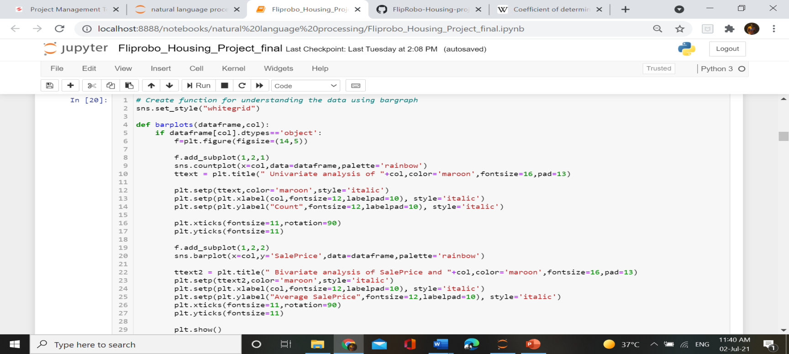

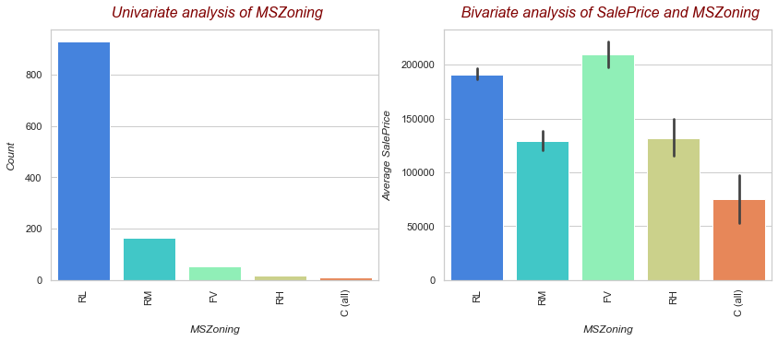

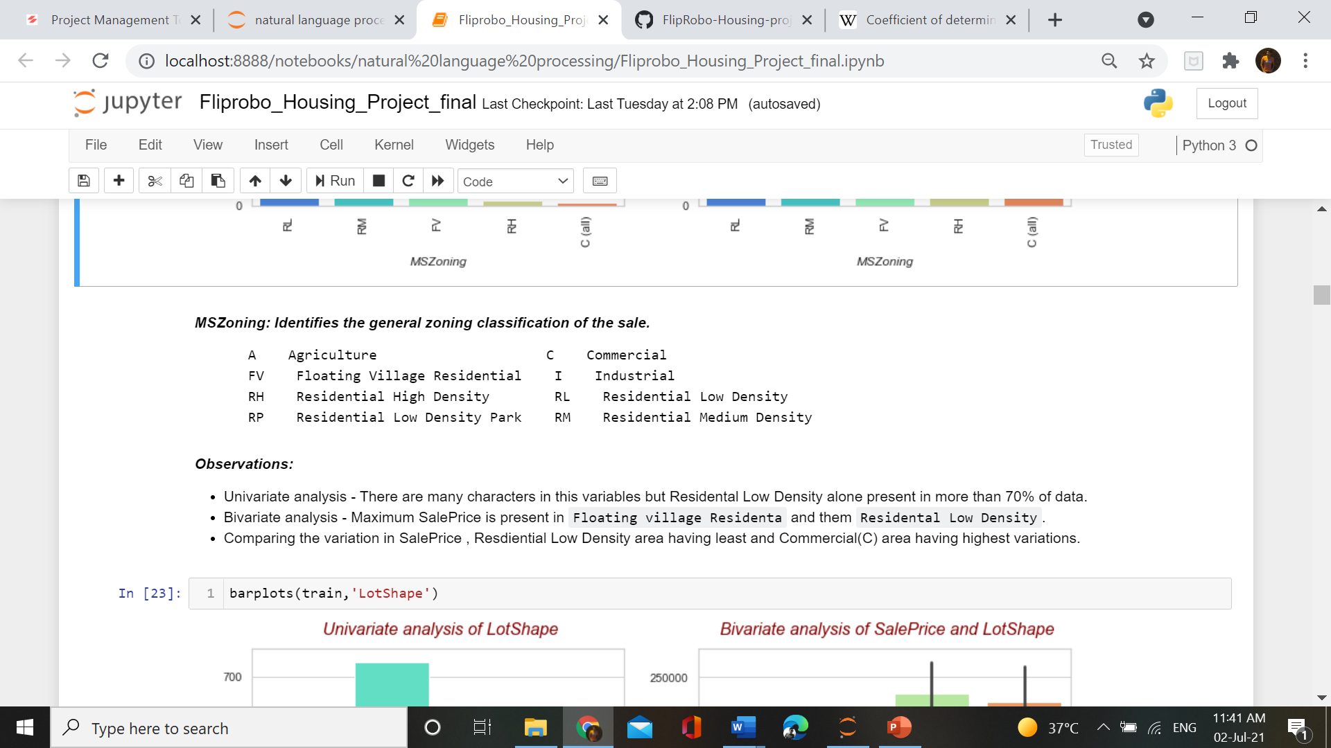

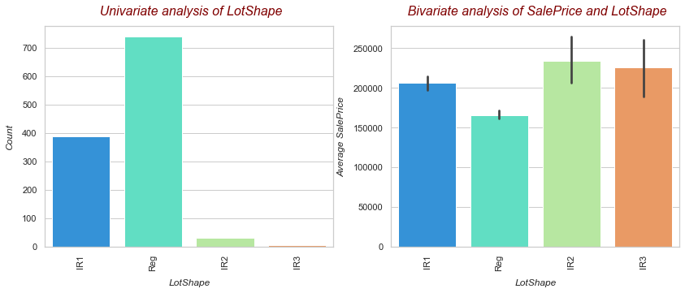

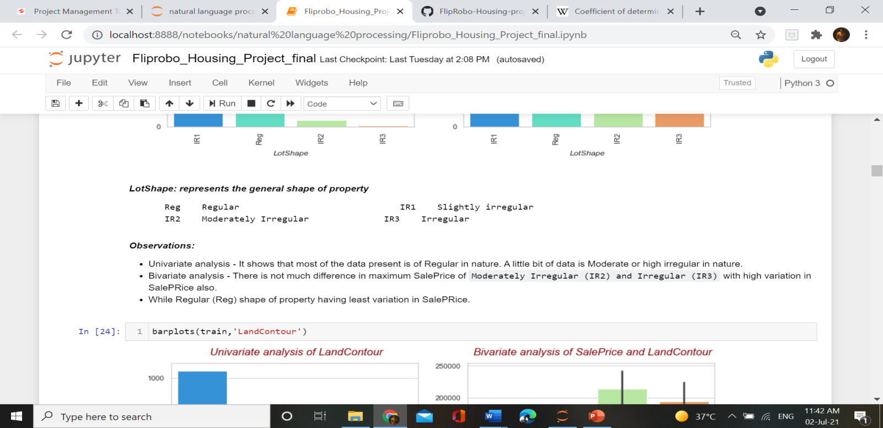

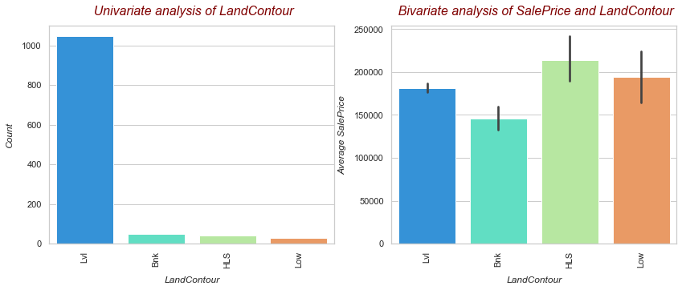

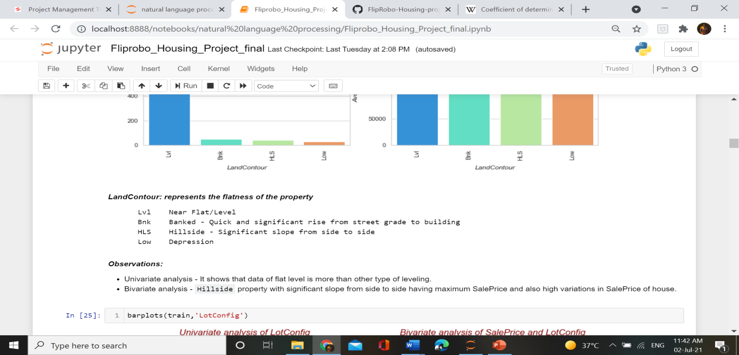

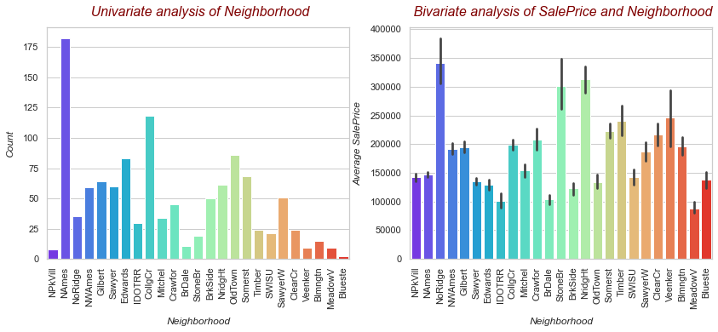

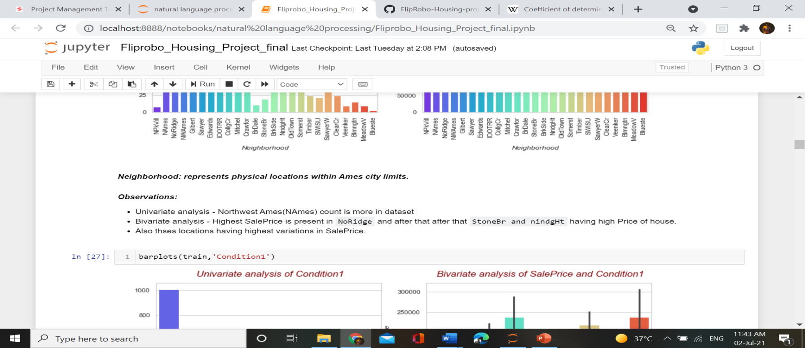

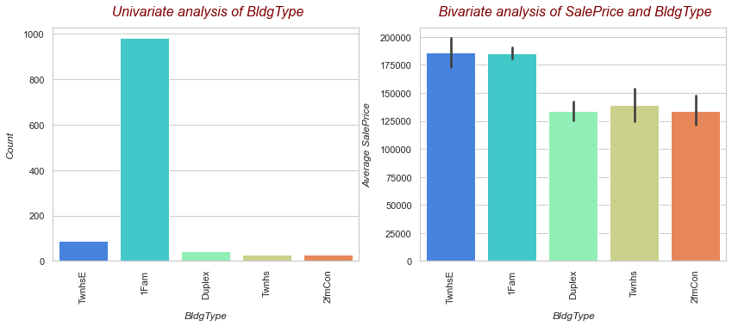

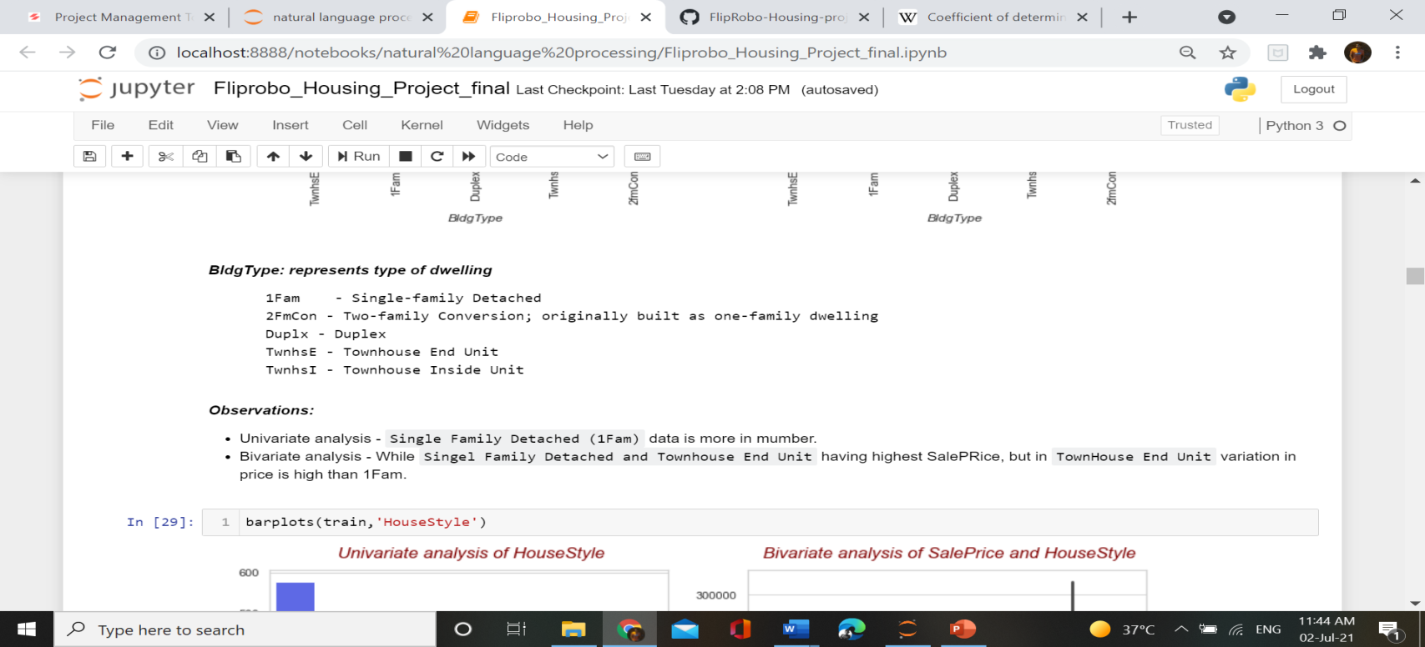

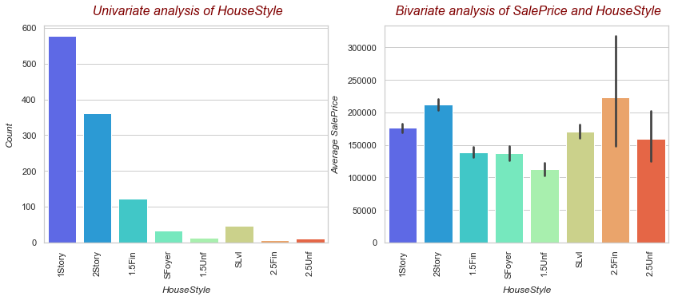

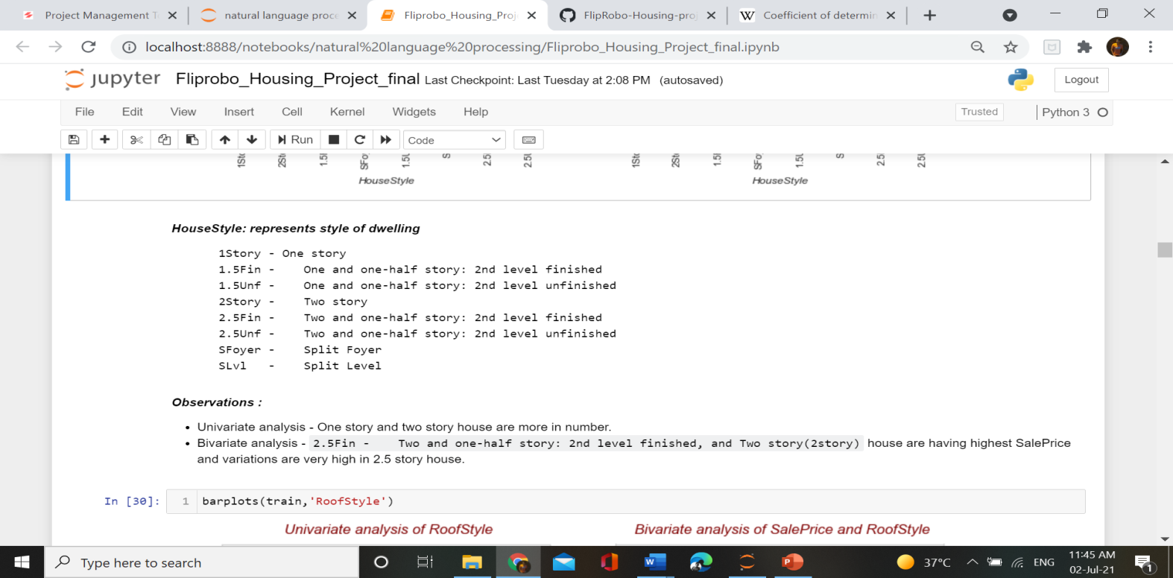

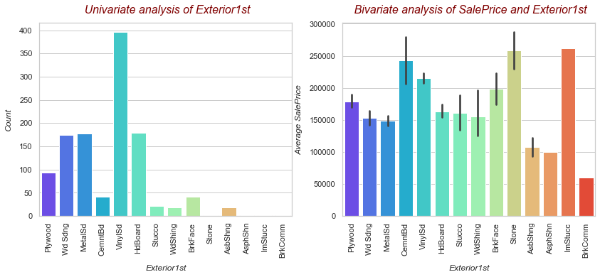

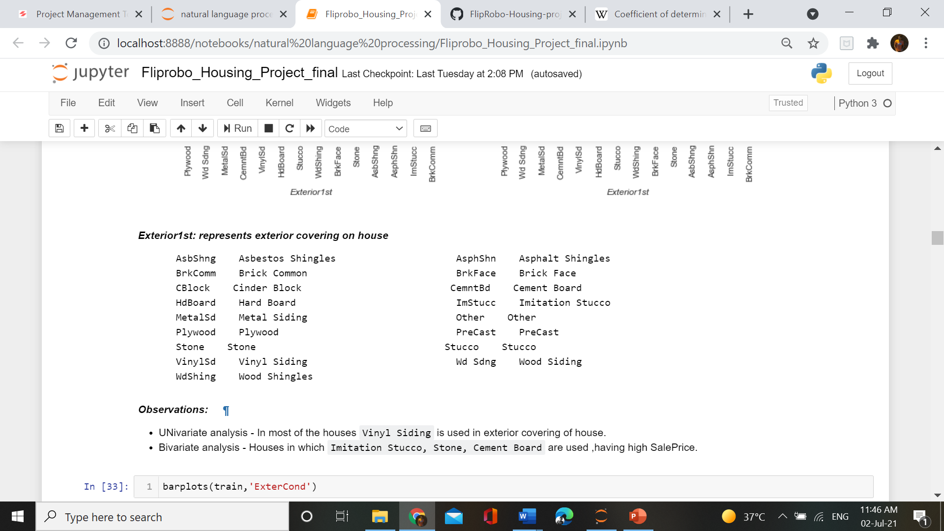

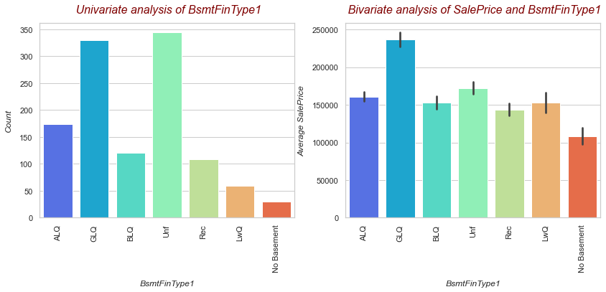

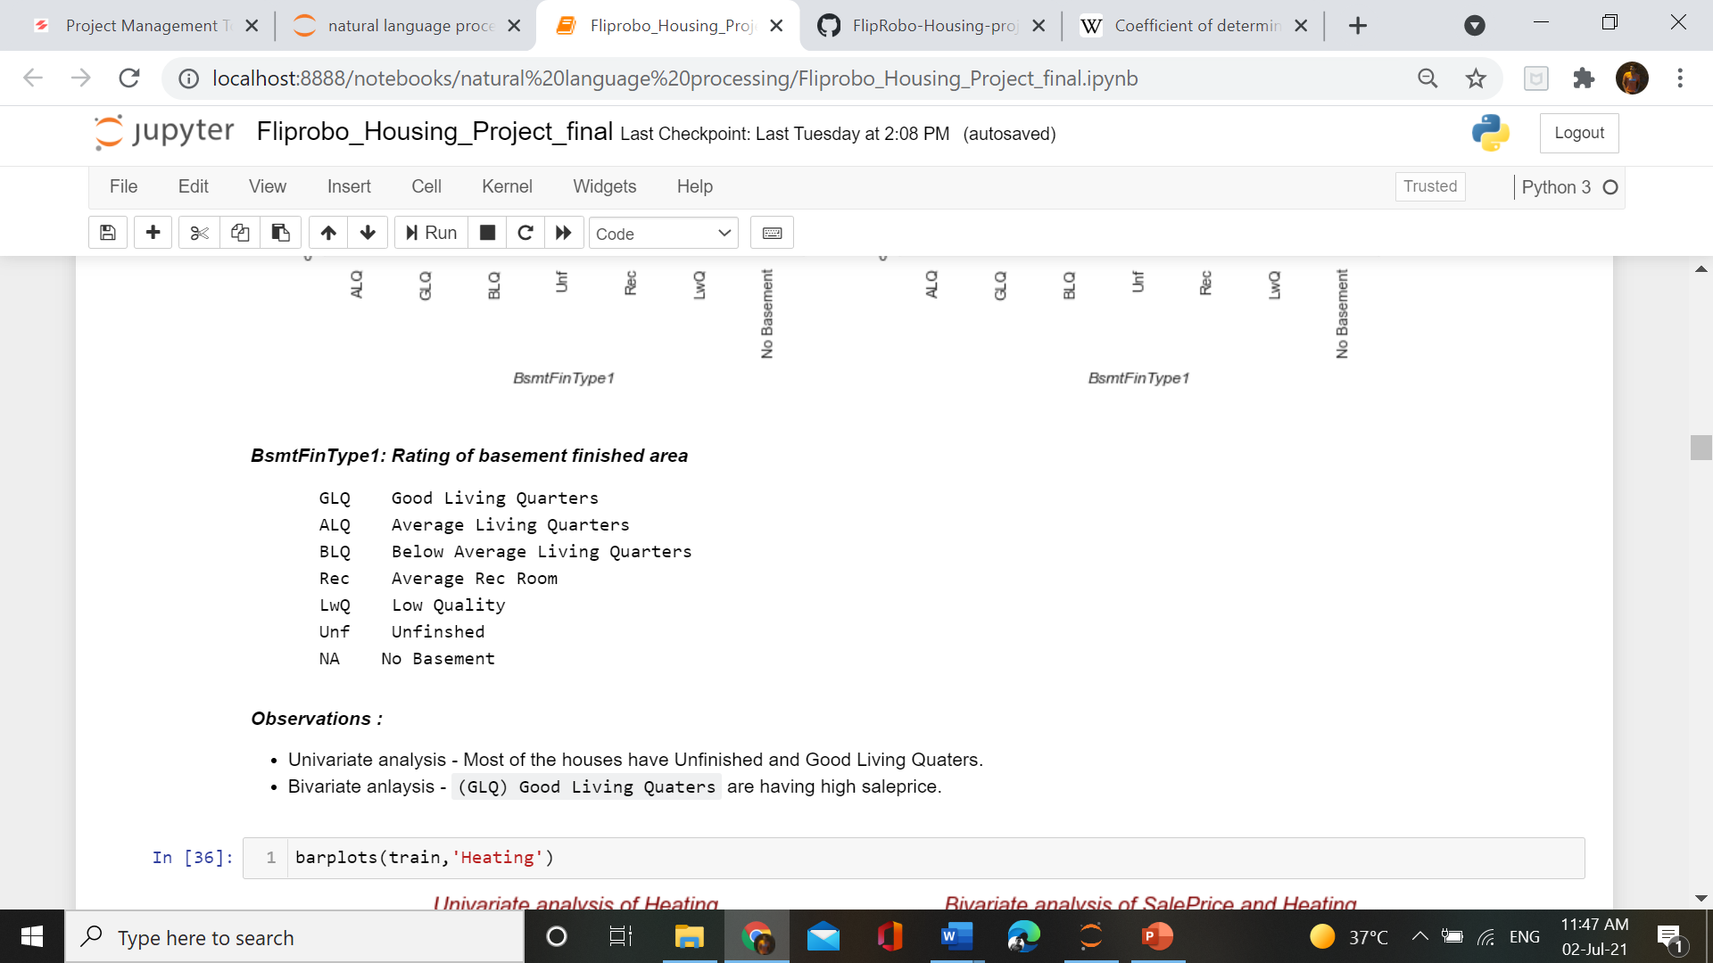

Distribution Plot -

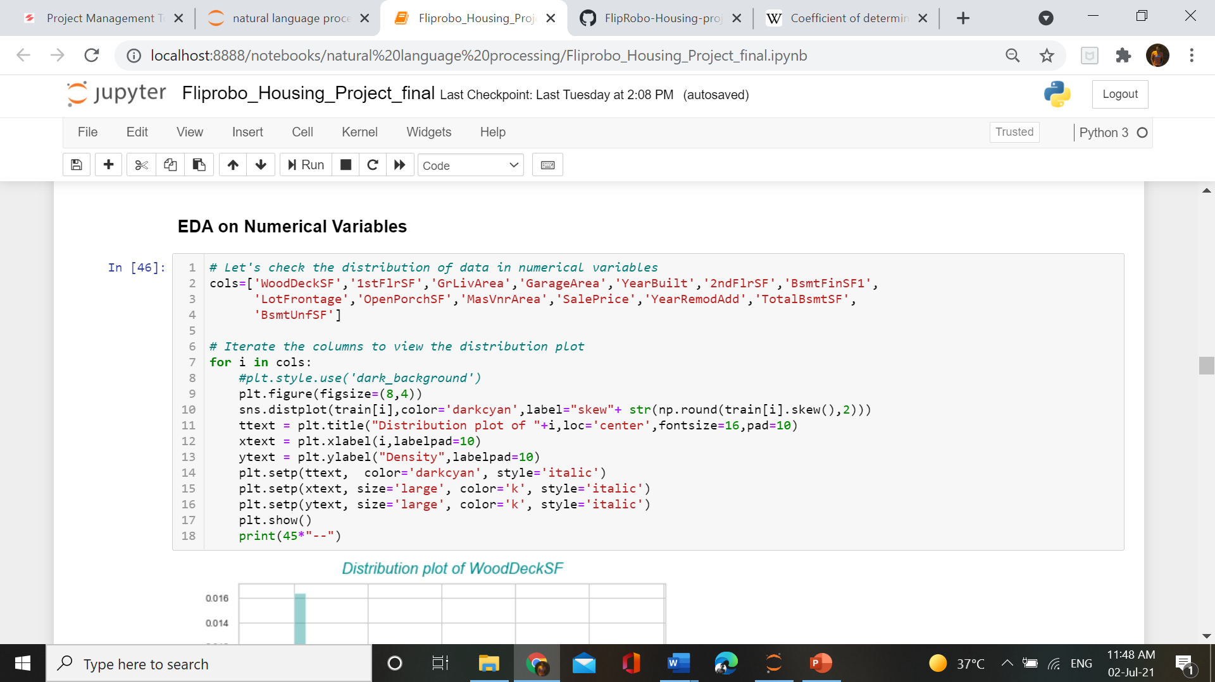

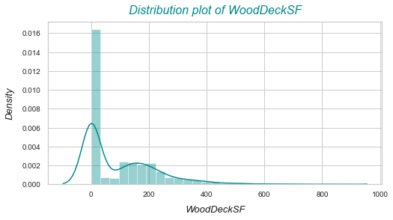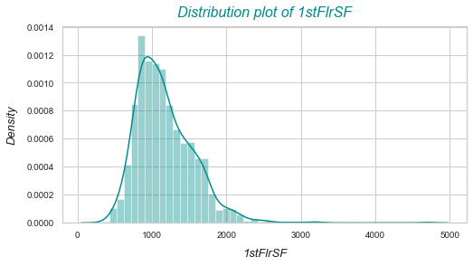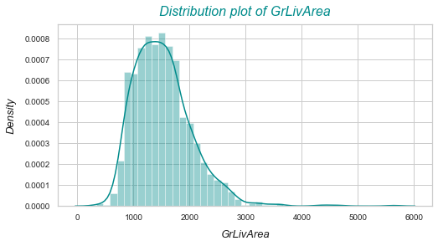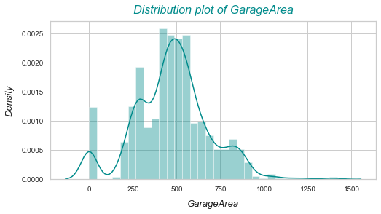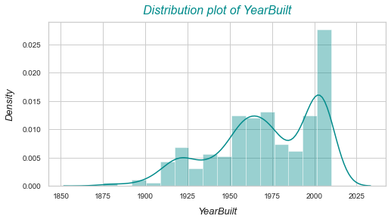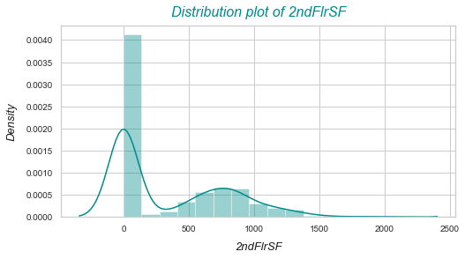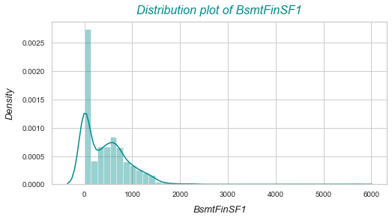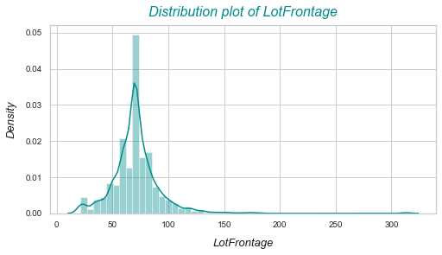

**Observations from Distplot :**

1. A lot of skewness is present in almost all the numerical columns.
2. Skewness in variables shows that data is not distributed well.
3. Except YearRemodAdd variables all other variables are right skewed.
4. Skewness in variables shows that data is not distributed well. We should treat outliers first.

Scatter and Regression Plot –

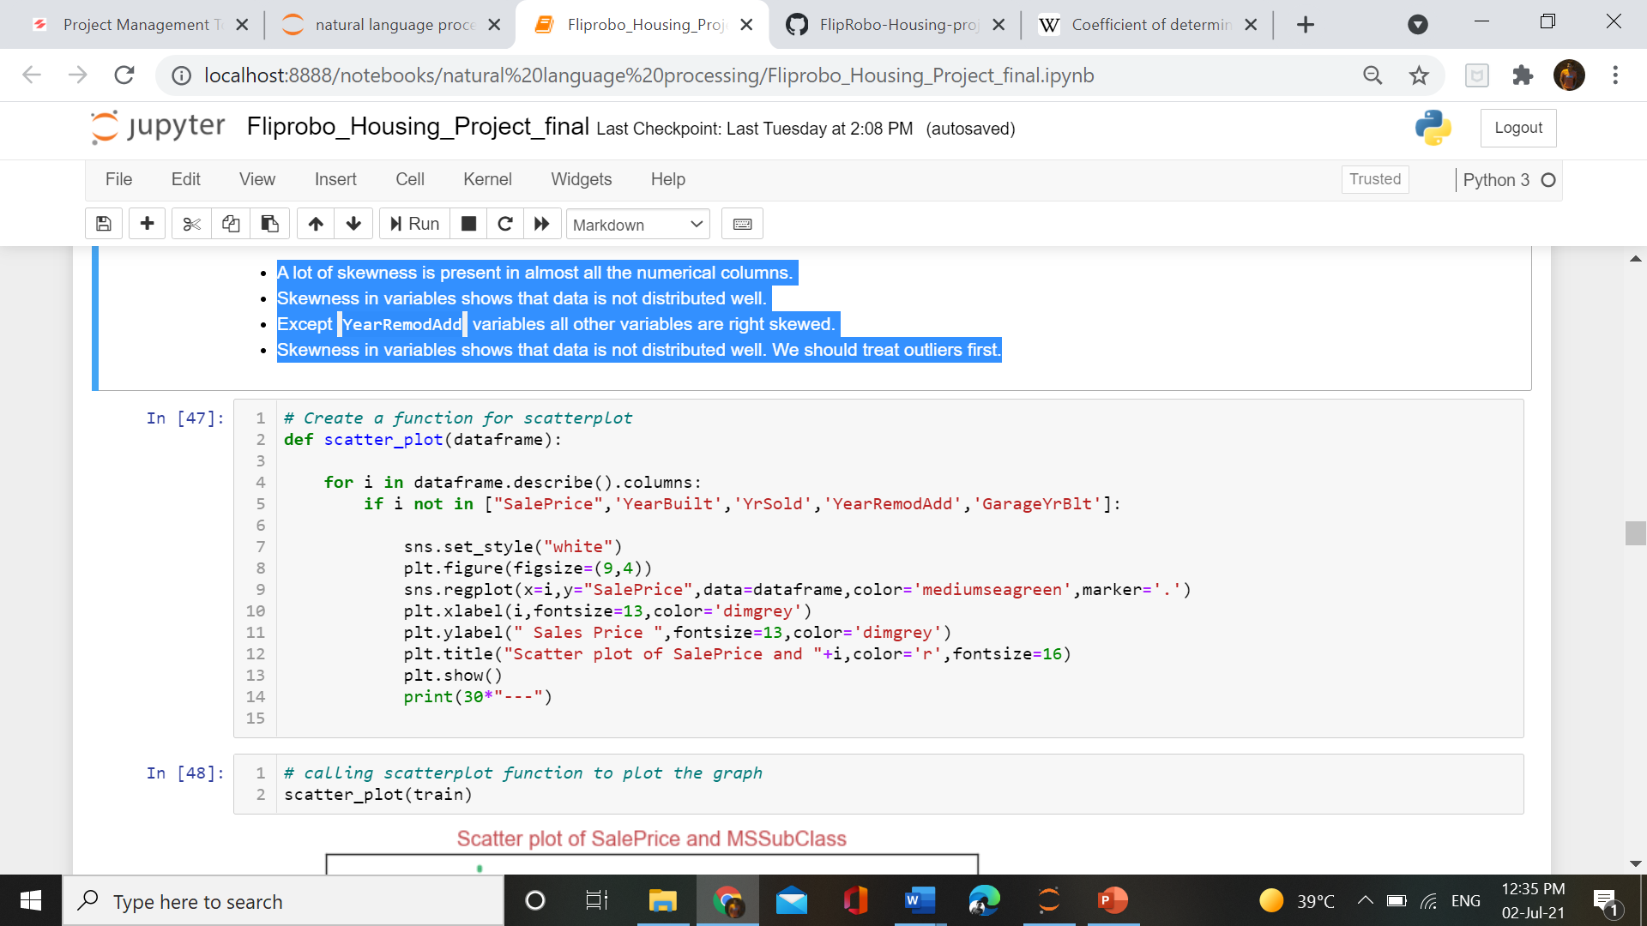

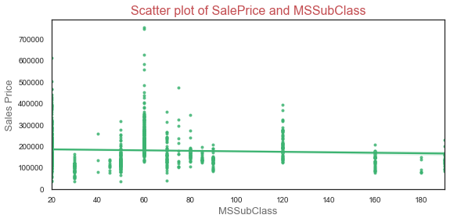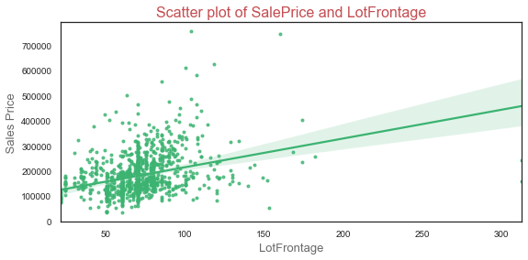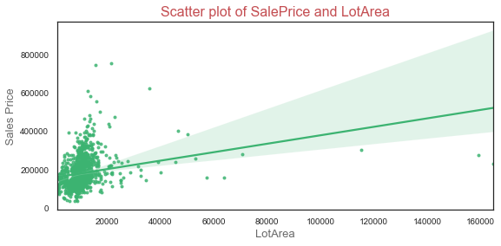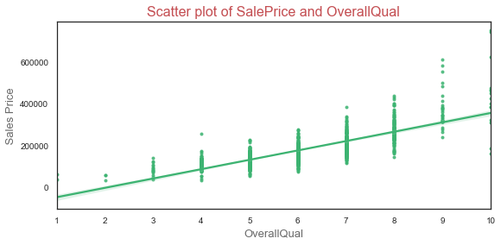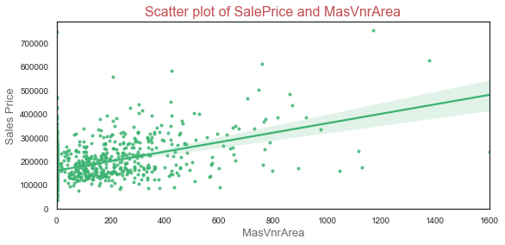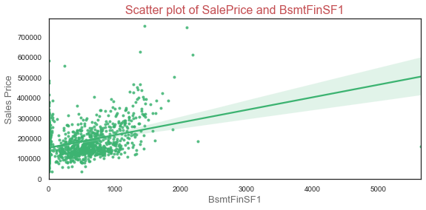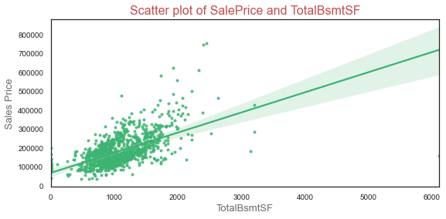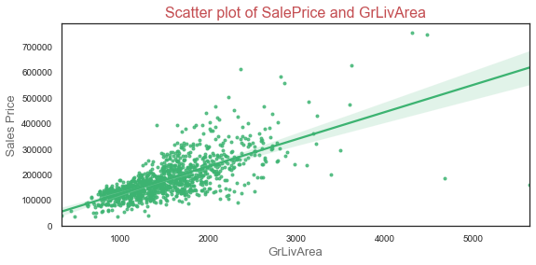

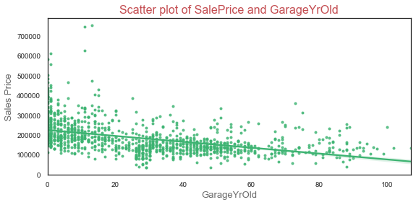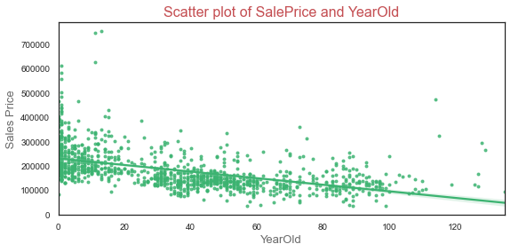

**Observations:**

1. Variables like KitchenAbvGrd is the most indirectly correlated variables with SalePrice.
2. We can cleary see that YearOld, GarageOld, YrOldRemod time related variabels are somehow showing some negative correltaion with SalePrice which means that as the age of house increase its SalePricedecreses and vice-versa,
3. While Mosold(Month of house sold year) showing almost no relation with salePrice which suggests that month of year has no effect on SalePrice but years having effect on SalePrice.

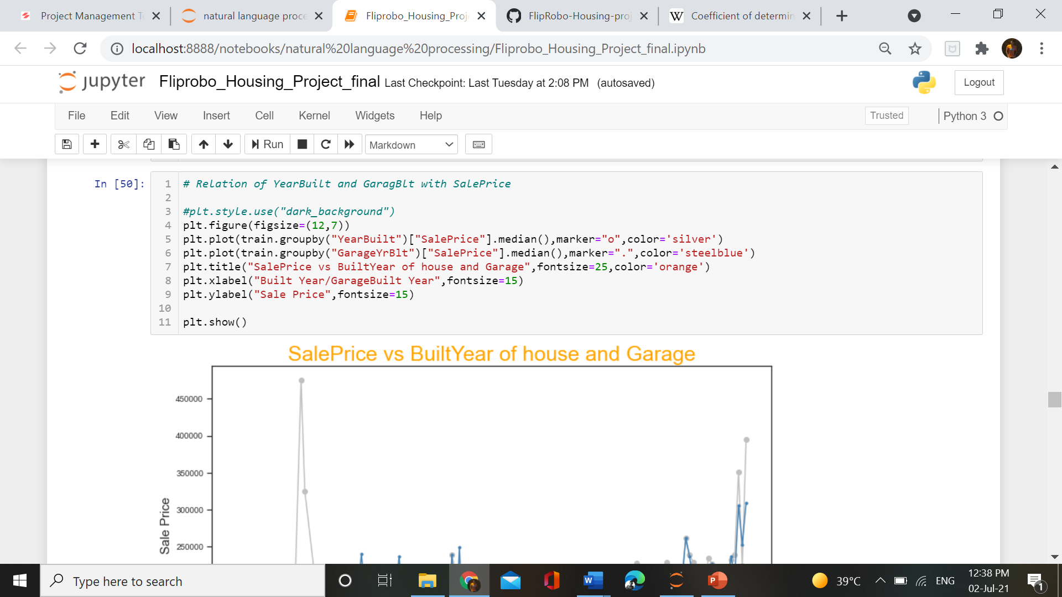

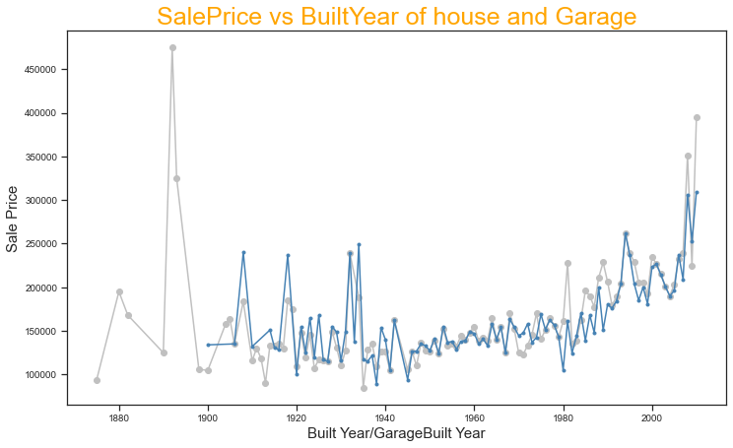

**Observations:**

1. Silver color of line represents the trend of SalePriceon the basis ofYearBuilt.
2. While blue color of line represents the trend of SalePriceon the basis ofGarageYrBlt.
3. Both the lines follow almost same trend which suggest that in most of the cases there is not much difference in Year of house and garage built.
4. But from trend line it is aslo clear that before 1900 there were no garage built for cars.

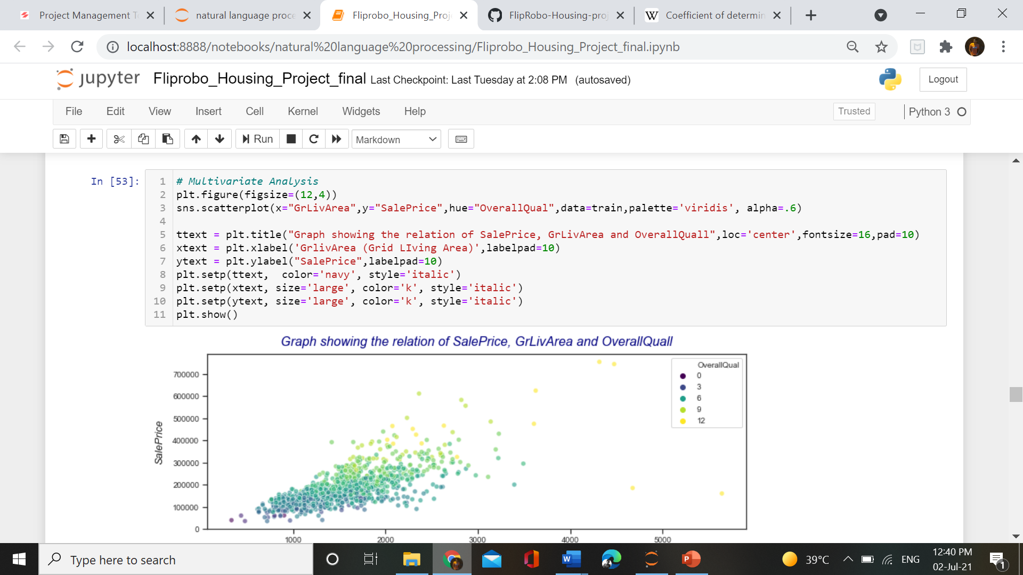

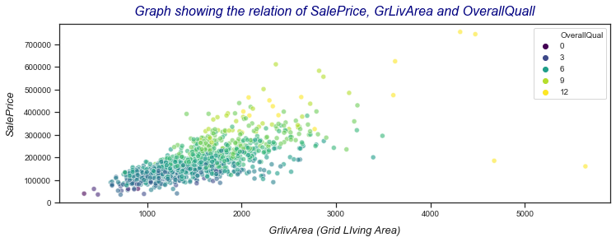

**Observations:**

1. Relation of above 3 variables shows that the if the GridLivArea increase and the OverallQuall also increase than the SalePrice of house is also going to increase.
2. All of the 3 variables are in direct relationship which means that any cahnge in GridLivArea or OverallQuall is going to change the SalePrice in the same way.
3. House with OverallQuall above 6 are having high saleprice.

* Interpretation of the Results

1. Variabel Street & Utilities having highly imbalanced dataset.
2. Utilities is having almost 100% of single character.
3. A lot of skewness is present in almost all the numerical columns.
4. Skewness in variables shows that data is not distributed well.
5. Except YearRemodAdd variables all other variables are right skewed.
6. Skewness in variables shows that data is not distributed well. We should treat outliers first.
7. Variables like KitchenAbvGrd is the most indirectly correlated variables with SalePrice.
8. We can cleary see that YearOld, GarageOld, YrOldRemod time related variabels are somehow showing some negative correltaion with SalePrice which means that as the age of house increase its SalePricedecreses and vice-versa,
9. While Mosold(Month of house sold year) showing almost no relation with salePrice which suggests that month of year has no effect on SalePrice but years having effect on SalePrice.
10. GarageArea and GarageCars are directly proportional to each other.
11. If the Gridliving area increases than TotalRmsAbvGrd are also going to increase.
12. if the GridLivArea increase and the OverallQuall also increase than the SalePrice of house is also going to increase.
13. GarageArea and OverallQualaslo having direct relationship with SalePrice.

**CONCLUSION**

* Key Findings and Conclusions of the Study

The key finding of the study is data there are a lot of factors which affects the price of a house.

Dealing with the Australian house data we find out that some of the major factors responsible for the high price of a house is Overall Quality of house, Garage area of House, GridLiving Area of house, Age of House and many more.

While understanding the categorical variables we find out that house with Wooden Finish on rooftop and Stone& Imitation Stucco on Exterior of house also have high price.

Some other factors responsible for high salepriceare :-

* Paved drive way is better preferred by people.
* Builtin garage type
* Good exposure of Basement
* Typical functionality of warranty
* Standard circuit breakers used in electrical work
* Gas used in heating
* Foundation of Concrete
* While neighbourhood in “NoRidge, StoneBr ,nindgHt”

All these are factors in property helps in high sale price of house.

* Learning Outcomes of the Study in respect of Data Science

This problem contains 81 columns among them some are irrelevant so I drop them and use remaining columns for model prediction. I also check null values in this dataset and make proper arrangement for that. I try to understand this problem by using various visualisation plots like bar plot, box plot, count plot etc. I have scaled the data and them send them into the model. In this problem the GradientBoosting Regression is performing very well according to its cross validation score and r2 score. We also use hyperparameter tunning on this algorithm and find the best result out of it.

* Limitations of this work and Scope for Future Work

It was a wonderful experience on working on this project. This project helps a lot in understanding new concepts and the new way of look towards the data but there are some limitations also in this project.

Too many columns – due to many columns it takes more time to understand andvisulaize the data .

A lot of missing values – We can gain more efficiency from the model if soo much missing values not be there.

Some columns contains many charaters which also decrease the efficiency of model.

Outliers – Treating outliers means changing the real data which is also not the ideal condition. As much as the real clean data be there , the model will perform well.

**Scope** –

This data helps a lot in understanding the conditions on which the price of a house depends. Now this model can be by companies for finding the best deal for their customers and helping them to expand their business and also will help people in finding their dream house in their budget.

Thankyou